**Cardiff Metropolitan University**

**B.Sc. (Hons) in Business Information Systems**

**Assignment Cover Sheet**

|  |  |  |  |  |  |  |  |  |  |
| --- | --- | --- | --- | --- | --- | --- | --- | --- | --- |
| **Student Details ( Student should fill the content)** | | | | | | | | | |
| Name | | | W.M. Veeshan Vimukthi Bandara | | | | | | |
| Student ID | | | st20267846 | | | | | | |
| **Scheduled unit details** | | | | | | | | | |
| Unit code | | | CIS6008 | | | | | | |
| Unit title | | | Analytics and Business Intelligence | | | | | | |
| Unit enrolment details | | | Year | | 3 | | | | |
| Study period | | 2023 | | | | |
| Lecturer | | | Assignment prepared by Induranga De Silva | | | | | | |
| Mode of delivery | | | Full Time | | | | | | |
| **Assignment Details** | | | | | | | | | |
| Nature of the Assessment | | | Coursework (a report) | | | | | | |
| Topic of the Case Study | | | Application of statistical and geospatial business analytics tools, techniques and methodologies to generate business intelligence essential for informed decision making in Power and Renewable Energy sector credible, efficient and effective informed decision making in Sri Lanka. | | | | | | |
| Learning Outcomes covered | | | LO2, LO3, LO4 | | | | | | |
| Word count | | | 3200(report) | | | | | | |
| Due date / Time | | | 06st August 2023 | | | | | | |
| Extension granted? | | | Yes | No | Extension Date | | |  | |
| Is this a resubmission? | | | Yes | No | Resubmission Date | | |  | |
| **Declaration** | | | | | | | | | |
| I certify that the attached material is my original work. No other person’s work or ideas have been used without acknowledgement. Except where I have clearly stated that I have used some of this material elsewhere, I have not presented it for examination / assessment in any other course or unit at this or any other institution | | | | | | | | | |
| Name/Signature | | | W.M. Veeshan Vimukthi Bandara | | | Date | | 2023.09.06 | |
| **Submission** | | | | | | | | | |
| Return to: | | |  | | | | | | |
| **Result** | | | | | | | | | |
| Marks by 1st Assessor |  | Name & Signature of the 1st Assessor | | | | |  | | **Agreed Mark** |
| Marks by2nd Assessor |  | Name & Signature of the 2nd Assessor | | | | |  | |
| Comments on the Agreed mark |  | | | | | | | | |

|  |  |  |  |  |  |  |  |  |  |
| --- | --- | --- | --- | --- | --- | --- | --- | --- | --- |
| **STUDENT NAME:** W.M. Veeshan Vimukthi Bandara  **CMU B.Sc. (HONS) BIS - ASSIGNMENT FEEDBACK SHEET –ICBT CAMPUS** | | | | | | | | | **STUDENT NUMBER:**  st20267846 |
| **Module Number & Title**: Analytics and Business Intelligence | | | | | | | | | **Semester: II** |
| **Assignment Type & Title:** Coursework  Application of statistical and geospatial business analytics tools, techniques, and methodologies to generate business intelligence essential for informed decision making in Power and Renewable Energy sector credible, efficient and effective informed decision making in Sri Lanka. | | | | | | | | | |
| **For student use: Critical feedback on the individual progression towards achieving the assignment outcomes** | | | | | | | | | |
|  | | | | | | | | | |
| **For the Assessors’ feedback**  **Indicate the Task number strength and Weaknesses and the marks for each task** | | | | | | | | | |
| **Task No/Question No** | **Strengths (1st Assessor)** | | | | | **Strengths (2nd Assessor)** | | | |
| **Task No / Question No** | **Weaknesses (1st Assessor)** | | | | | **Weaknesses (2nd Assessor)** | | | |
| **Areas for future improvement** | | | | | | | | | |
| **Comments by 1st Assessor** | | | | | | | **Comments by 2nd Assessor** | | |
| **Marks** | | | | | | | | | |
| **Task /Question No** | | **Marks by 1st Assessor** | **Marks by 2nd Assessor** | | **Marks by IV (if any)** | | **IV comments (If Any)** | | |
|  | |  |  | |  | |  | | |
|  | |  |  | |  | |
|  | |  |  | |  | |
| **Total Marks** | |  |  | |  | |
| **Name and the Signature of the 1st Assessor** | | | |  | | | **Date:** |  | |
| **Name & Signature of the 2ndAssessor :** | | | |  | | | **Date :** |  | |
| **Name & Signature of the IV: (If any)** | | | |  | | | **Date :** |  | |

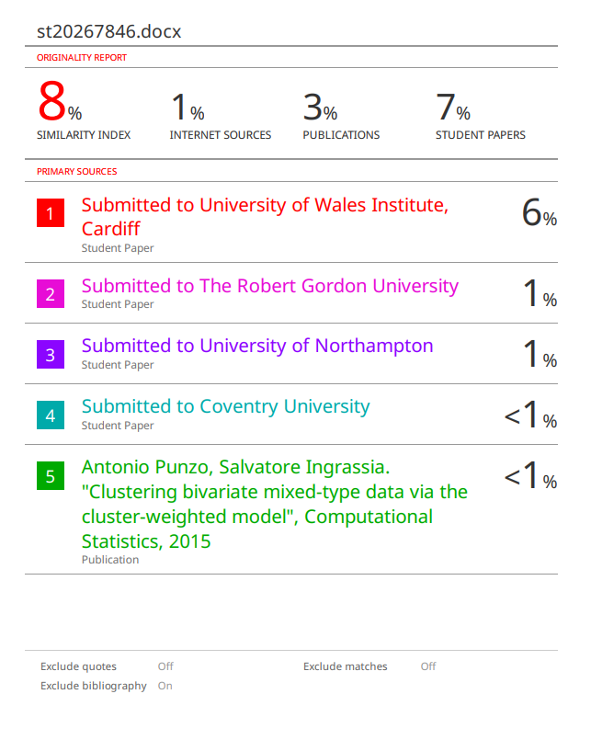

# ACKNOWLEDGEMENT

Foremost, we the students of BSc in Computing & Software Engineering, batch 10 would like to express our sincere gratitude and appreciation to Mr. Asanka Dinesh, lecturer in Analytics and Business Intelligence for him continuous support, patience, motivation, enthusiasm, and immense Besides our lecturer, we would like to thank our seniors, who had been providing guidance and support for the completion of our assignment and presentation.

Moreover, we would like to express gratitude and appreciation to each other for providing continuous support, enthusiasm, and knowledge in completing the project, assignment.

Further, we would like to express our gratitude to all the ICBT management and staff for being extremely friendly, welcoming and for providing us with this opportunity to present our talents and ideas via an assignment and a presentation. Finally, I would like to express our sincere gratitude to our families for providing moral support and a positive environment throughout the journey.

# EXECUTIVE SUMMARY

The Ministry of Power and Renewable Energy is actively addressing the nation's rising power demand through research initiatives. Focus is on improving energy efficiency in building cooling systems, which contribute significantly to overall electricity consumption. We employ tools like R, R-Studio, QGIS, and PostgreSQL for data analysis. The project aims to create precise statistical models, considering unique Sri Lankan energy consumption patterns and building structures. An interactive map identifies optimal sites for solar power plants, contributing to energy solutions. A PostgreSQL geospatial database, "SLPetrolium-2023," aids in visualizing petrol and diesel distribution, and renewable energy sites are identified. Finally, potential locations for a regional renewable energy research center in the Kandy region are assessed, aiming to meet Sri Lanka's increasing energy needs.

# TABLE OF CONTENTS

ACKNOWLEDGEMENT I

EXECUTIVE SUMMARY VI

TABLE OF CONTENTS VII

LIST OF FIGURES IX

LIST OF TABLES XI

ABBREVIATIONS XII

INTRODUCTION 1

Chapter 1 3

Task A 3

1.1. Add libraries. 3

1.2. Load the data set. 4

1.3. Data preprocessing 4

1.4. Bell curves for Cooling data distributions 5

1.5. Scatterplot matrix 5

1.6. Full dataset Summary of lanner regression 6

Chapter 2 8

Task B 8

2.1. Regression Analyst 8

2.1.1.1. Hypothesis Statement 8

2.1.1.2. Linear model 8

2.1.1.3. Summary Statistic for lm () Function 9

2.1.1.4. Scatter Plot 10

2.1.2. Cooling Load and Relative Compactness 10

2.1.2.1. Hypothesis Statement 10

2.1.2.2. Linear model 11

2.1.2.3. Summary Statistic for lm () Function 11

2.1.3. Cooling Load and Overall Height 12

2.1.3.1. Hypothesis Statement 12

2.1.3.2. Linear model 13

2.1.3.3. Summary Statistic for lm () Function 13

2.1.3.4. Scatter plot 14

2.1.4. Cooling Load and Glazing Area 14

2.1.4.1. Hypothesis Statement 14

2.1.4.2. Linear model 15

2.1.4.3. Summary Statistic for lm () Function 15

2.1.4.4. Scatter plot 16

2.1.4.5. Full model Scatter plot 16

Chapter 3 18

Task C 18

Chapter 4 22

Task D 22

Chapter 5 25

Task E 25

Chapter 6 27

Task F 27

Chapter 7 31

Task G 31

Chapter 8 37

Task H 37

Conclusion 40

Reference xli

## LIST OF FIGURES

Figure 1‑1 Import dataset and print Head of dataset 4

Figure 1‑2 Dataset visualization 4

Figure 1‑3 Data preprocessing (remove null values ,summary, check null values 4

Figure 1‑4 Output data preprocessing 4

Figure 1‑5 Bell curves for Cooling data distributions 5

Figure 1‑6 Scatterplot Code 5

Figure 1‑7 Scatterplot Metrix 6

Figure 1‑8 Full dataset Summary of lanner regression 6

Figure 1‑9 Output Full dataset Summary of lanner regression. 7

Figure 2‑1 lm () function to find coefficients. 8

Figure 2‑2 Summary statistic function for the given lm () function 9

Figure 2‑3 Scatterplot of Cooling Load vs. Heating Load 10

Figure 2‑4 lm () function to find coefficients. 11

Figure 2‑5 Summary statistic function for the given lm () function 11

Figure 2‑6 Scatterplot of Cooling Load vs. Relative Compactness 12

Figure 2‑7 lm () function to find coefficients. 13

Figure 2‑8 Summary statistic function for the given lm () function 13

Figure 2‑9 Scatterplot of Cooling Load vs. Overall Height 14

Figure 2‑10 lm () function to find coefficients. 15

Figure 2‑11 Summary statistic function for the given lm () function 15

Figure 2‑12 Scatterplot of Cooling Load vs. Glazing Area 16

Figure 2‑13 Full model Scatter plot code 16

Figure 2‑14 Full model Scatter plot 17

Figure 3‑1 SLWindPowerLand_21_23 Dataset 18

Figure 3‑2 Sri Lanka feasible lands for Wind Power development 19

Figure 3‑3 Sri Lanka feasible lands for Wind Power development 20

Figure 4‑1Estimated Energy dataset. 22

Figure 4‑2 Available land for solar power development 23

Figure 5‑1 Digitalized Map Of Solar Power Energy in Hambantota 25

Figure 6‑1 Number of sheds, Gasoline, and diesel dataset 27

Figure 6‑2 Descriptive Statistics on Gasoline and Diesel Sheds - 2023 28

Figure 6‑3 Descriptive Statistics on Gasoline usage - 2023 29

Figure 7‑1 Potential Location For Renewable Energy Generation In Sri Lanka(solar, wind, Biomass) 32

Figure 7‑2 Potential Location For Renewable Energy Generation In Sri Lanka (solar) 34

Figure 7‑3 Potential Location For Renewable Energy Generation In Sri Lanka (Wind) 35

Figure 7‑4 Potential Location For Renewable Energy Generation In Sri Lanka (Biomass) 36

Figure 8‑1 Renewable Energy Regional Research Centre for Kandy 37

Figure 8‑2 Renewable Energy Regional Research canter for Kandy (sutable area) 38

Figure 8‑3 Total number of buildings, Total land area, Suitable land area 38

# LIST OF TABLES

Table 1‑1 Categorical and Continuous value 3

Table 1‑2 Impor necessary libraries 3

Table 2‑1 Cooling load and the Heating Load Hypothesis Statement 8

Table 2‑2 Cooling load and the Relative Compactness Hypothesis Statement 10

Table 2‑3 Cooling load and the Overall Height Hypothesis Statement 12

Table 2‑4 Cooling load and the Glazing Area Hypothesis Statement 14

Table 3‑1 Provinces wise Total area(ha) 21

Table 4‑1Province wise Total estimated energy 24

# ABBREVIATIONS

|  |  |
| --- | --- |
| DEA | Data Analysis and Visualization for Energy Efficiency |
| DSM | Development of Statistical Models |
| WPDM | Wind Power Development Map |
| SPDM | Solar Power Development Map |
| DAM | Digitized Area Map |
| REGM | Renewable Energy Generation Locations Map |

## Abstraction

The Ministry of Power and Renewable Energy is actively engaged in research initiatives aimed at addressing pressing issues in power generation to meet the escalating energy demands of the nation. This comprehensive project encompasses multiple facets, including enhancing energy efficiency in building cooling systems, creating statistical models to understand the relationships between building cooling and structural elements, and generating digital maps highlighting potential solar power plant locations and other vital geographical features. Additionally, the project involves the development of a PostgreSQL geospatial database, "SLPetrolium-2023," to manage data related to petrol and diesel usage and produce thematic maps illustrating their distribution. Furthermore, potential sites for renewable energy production, in collaboration with the Sri Lanka Sustainable Energy Authority, are being identified. The project's culmination lies in the creation of a map depicting potential locations for a regional research center focused on renewable energy in the Kandy region, supported by a rigorous suitability analysis. This multifaceted endeavor seeks to address energy efficiency, renewable energy integration, and sustainable energy practices, aligning with Sri Lanka's evolving energy needs and challenges.

# INTRODUCTION

The Ministry of Power and Renewable Energy is actively involved in research projects designed to address current issues with power generation to fulfil the nation's rising demand. Enhancing energy efficiency in building cooling systems is a major area of concentration to lower residential and commercial power usage, which accounts for a sizeable amount of the nation's overall electricity demand. To accomplish these aims, a dataset called "energy_efficiency_data.csv" and an associated data dictionary has been made available to investigate any potential relationships between building cooling and other building structural variables connected to building forms. R, R-studio, QGIS and PostgreSQL will be used to complete these tasks.

The results of the first investigation will be used in the final phase of this project to create accurate statistical models that capture the relationships between building cooling and related structural elements. These models use tools such as R, R-studio, and R-commander and will be informed by the given data set. Additional critical analysis will be done on models produced in Sri Lanka's unique energy consumption patterns and building architecture.

The task also comprises creating a digitally enhanced informational area map that highlights the probable locations for solar power plant construction as well as other pertinent elements like structures, roads, trees, and woods. Utilising readily accessible geospatial technologies like QGIS and open-layer plugins, the digitization process will produce a map that will be examined to see how well solar energy would be able to handle Sri Lanka's energy sector's problems.

While developing a PostgreSQL geospatial database named "SLPetrolium-2023" to store information on petrol and diesel usage. Shapefiles and data of district-level statistics including the number of sheds and mean, and standard deviation of petrol and diesel usage are stored in the database. It also creates thematic maps to gain an understanding of the distribution of the use of petroleum products. The project also includes identifying potential places to produce renewable energy as determined by the Sri Lanka Sustainable Energy Authority.

The development of a map showing potential locations for a regional research centre for renewable energy in the Kandy region marks the completion of the job. Along with a rigorous analysis of the appropriateness of the chosen location, the map shows the total number of nearby structures, the space occupied by these buildings, and the overall amount of suitable territory.

# 

## Task A

To solve the problems related to demand-driven power generation, the Ministry of Power and Renewable Energy is looking for new solutions through regional and international research. A key area of focus is improving the energy efficiency of building cooling systems, which are essential to reducing home and business energy use. Thus, the data set "energy_efficiency_data.csv" and R-studio or R-studio Cloud tools are used. To accomplish this task, potential relationships between building cooling and structural factors will be analyzed. According to the data set provided, it is classified as categorical and continues to be. Thus, the following analysis was conducted using continuous factors.

|  |  |
| --- | --- |
| **Continue** | **Categorical** |
| Relative Compactness | Orientation |
| Surface Area | Glazing Area Distribution |
| Wall Area | - |
| Roof Area | - |
| Overall Height | - |
| Glazing Area | - |
| Heating Load | - |
| Cooling Load | - |

Table 1‑1 Categorical and Continuous value

### Add libraries.

When performing this analysis, the required libraries are first imported. They are Rcmdr, Gggplot2, GridExtra(Millán-Martínez and Oller, 2020).



Table 1‑2 Impor necessary libraries

### Load the data set.

Second, the energy_efficiency_data.csv data set is read. Accordingly, the factors of that dataset are Relative Compactness, Surface Area, Wall Area, Roof Area, Overall Height, Orientation, Glazing Area, Glazing Area Distribution, Heating Load, Cooling Load.

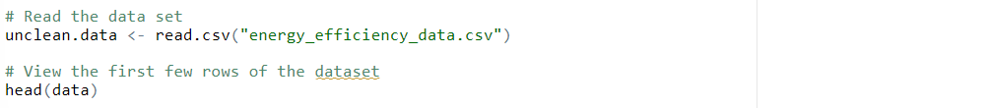

Figure 1‑1 Import dataset and print Head of dataset

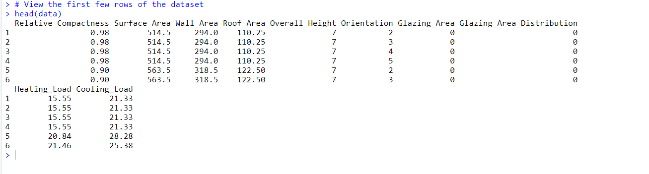

Figure 1‑2 Dataset visualization

### Data preprocessing

As the next step, the data preprocessing part is done. Accordingly, removing the null value of the dataset, the summary of the dataset is obtained. According to this summary, min, max, median, mean have been determined. Also, it has been checked again whether there are null values in the dataset.

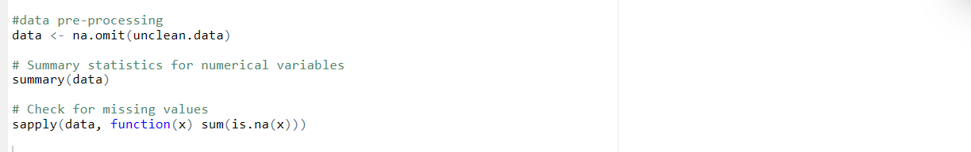

Figure 1‑3 Data preprocessing (remove null values ,summary, check null values

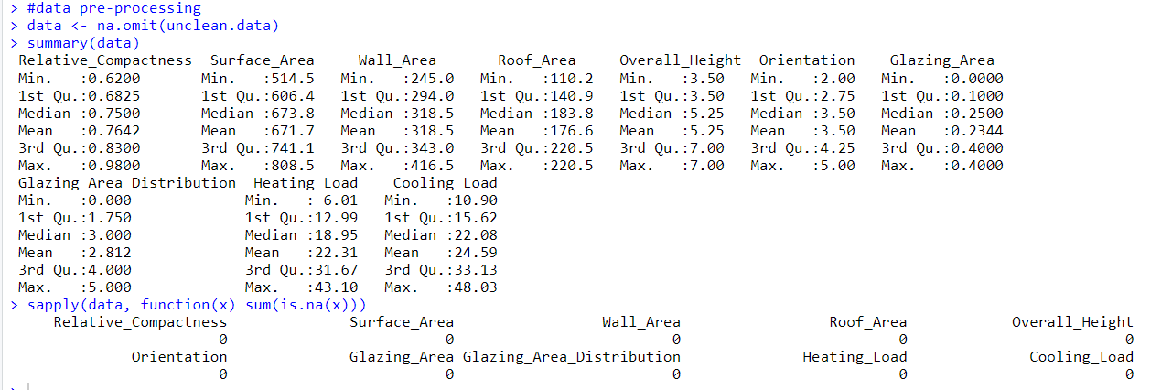

Figure 1‑4 Output data preprocessing

### Bell curves for Cooling data distributions

The Bell curve chart below illustrates the data distribution by cooling load in the data set. Thus, the peak of the curve at the centre represents the mean or average value of the data set. Furthermore, the spread or dispersion of the data in this dataset is expressed in terms of the standard deviation. Thus, this is referred to as a Multimodal Distribution.

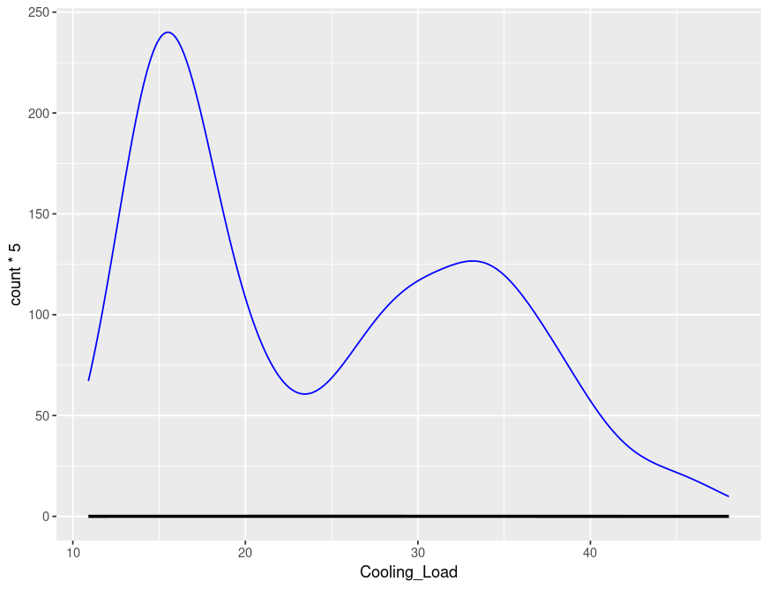

Figure 1‑5 Bell curves for Cooling data distributions

### Scatterplot matrix

The following scatterplot shows the structural factors of a building. According to those factors, the relationship of the structural factors changes according to the chilling load of the building. Thus, a positive relationship between the cooling load and the heating load is expressed. Also, there is a negative relationship between Surface Area and Relative Compactness, and between Wall Area and Relative Compactness. Another positive relationship exists between Surface Area and Wall Area.



Figure 1‑6 Scatterplot Code

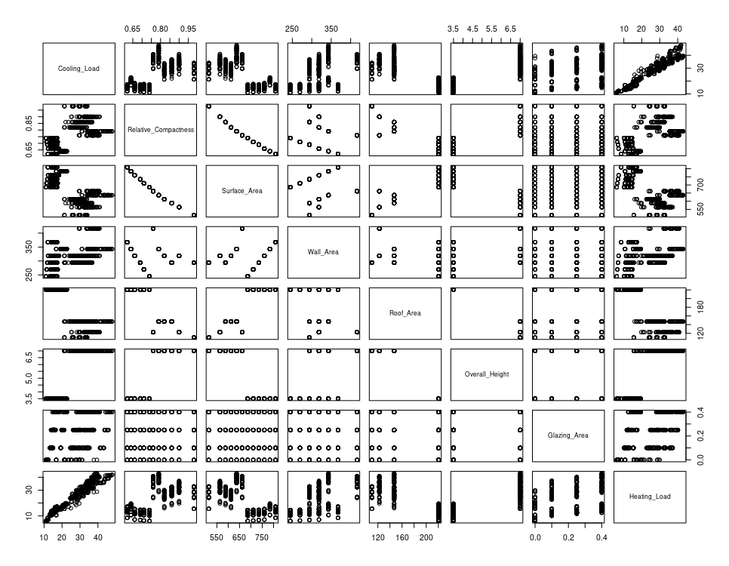

Figure 1‑7 Scatterplot Metrix

### Full dataset Summary of linear regression

According to continues value, a model should be developed to examine the relationship between a building's cooling load and other variables. The model prepared for that is described below. According to the summary statics obtained according to that model, the relationship is shown as described above.

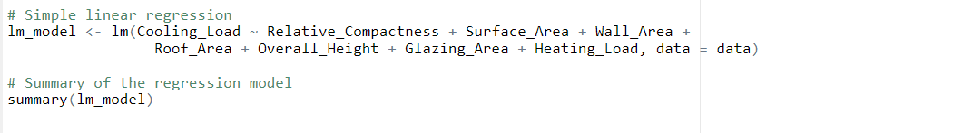

Figure 1‑8 Full dataset Summary of linear regression

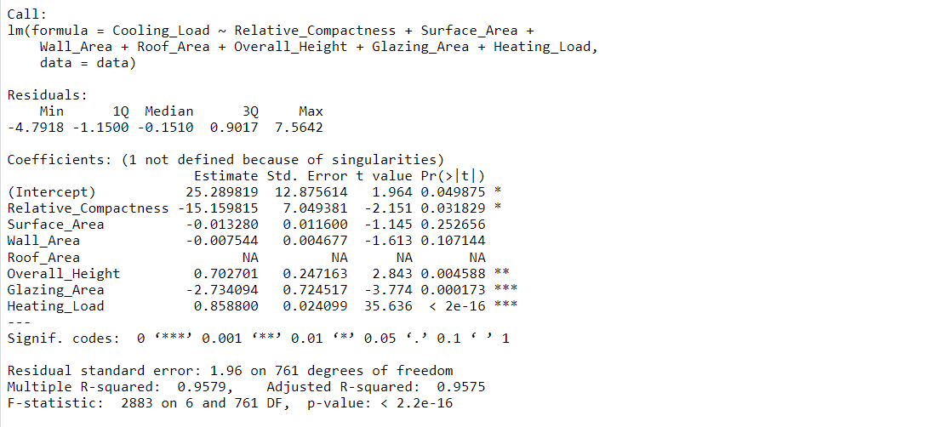

Figure 1‑9 Output Full dataset Summary of lanner regression.

# 

## Task B



### Regression Analyst

A statistical model has been prepared for the relationship through the above task. Accordingly, in this task, the creation of a statistical model as well as the related Hypothesis Statement and summary statics have been used. This will make an analysis.(Ansari and Nassif, 2022)

##### Hypothesis Statement

|  |  |
| --- | --- |
| H0 | There is no significant relationship between the Cooling load and the Heating Load of the building |
| H1 | There is a significant relationship between the Cooling load and the Heating Load of the building |

Table 2‑1 Cooling load and the Heating Load Hypothesis Statement

Significance level (x) = 0.05

Confidence level = 95%

##### Linear model

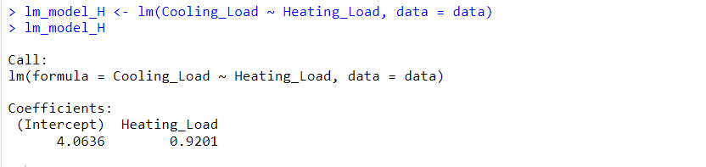

Figure 2‑1 lm () function to find coefficients.

𝑌 data$Cooling_Load = 4.06 + 0.92 𝑋 data$Heating_Load

##### Summary Statistic for lm () Function

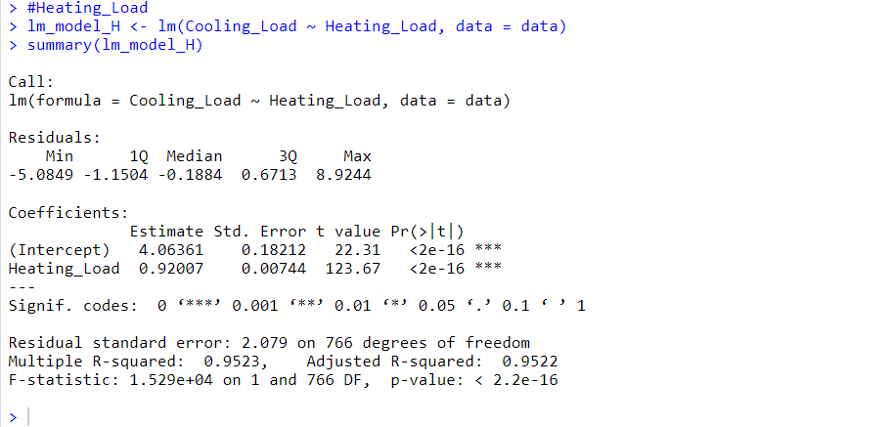

Figure 2‑2 Summary statistic function for the given lm () function

Decision: p-value = 2.2e-16 <x = 0.05> Reject H0

An incredibly small p-value of 2.2e-16 for the relationship between Cooling Load and heating load has a strong and statistically significant correlation. At a significance level of 0.05, which is commonly used in hypothesis testing, we have significant evidence to reject the null hypothesis. Therefore, there is a significant relationship between cooling load and heating load.

##### Scatter Plot

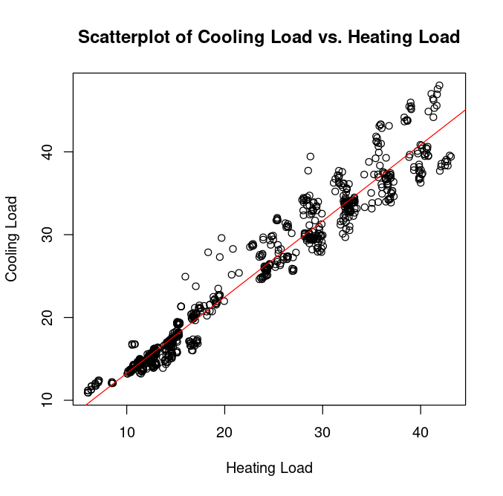

Figure 2‑3 Scatterplot of Cooling Load vs. Heating Load

#### Cooling Load and Relative Compactness

##### Hypothesis Statement

|  |  |
| --- | --- |
| H0 | There is no significant relationship between the Cooling load and the Relative Compactness of the building |
| H1 | There is a significant relationship between the Cooling load and the Relative Compactness of the building |

Table 2‑2 Cooling load and the Relative Compactness Hypothesis Statement

Significance level (x) = 0.05

Confidence level = 95%

##### Linear model

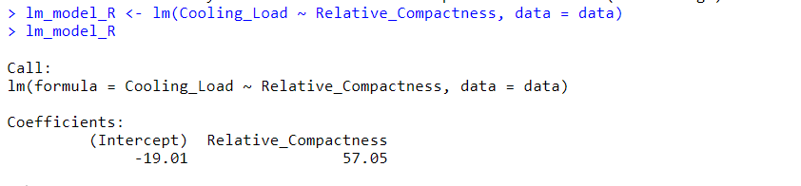

Figure 2‑4 lm () function to find coefficients.

𝑌 data$Cooling_Load = -19.0 + 57.05 𝑋 data$ Relative_Compactness

##### Summary Statistic for lm () Function

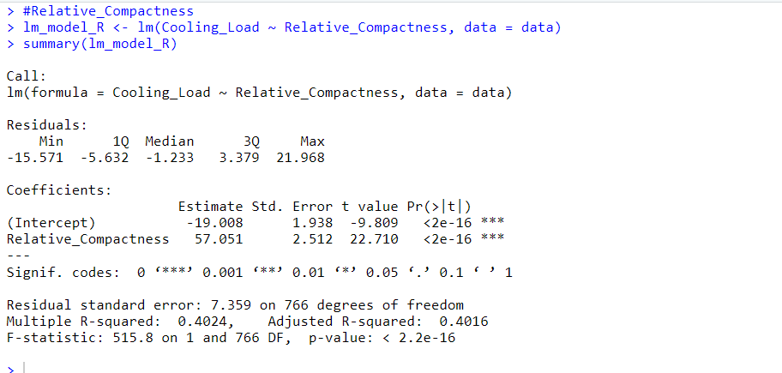

Figure 2‑5 Summary statistic function for the given lm () function

Decision: p-value = 2.2e-16 <x = 0.05> Reject H0

An incredibly small p-value of 2.2e-16 for the relationship between cooling load and relative compactness has a strong and statistically significant correlation. At a significance level of 0.05, which is commonly used in hypothesis testing, we have significant evidence to reject the null hypothesis. Therefore, there is a significant relationship between relative compactness and heating load.

Scatter Plot

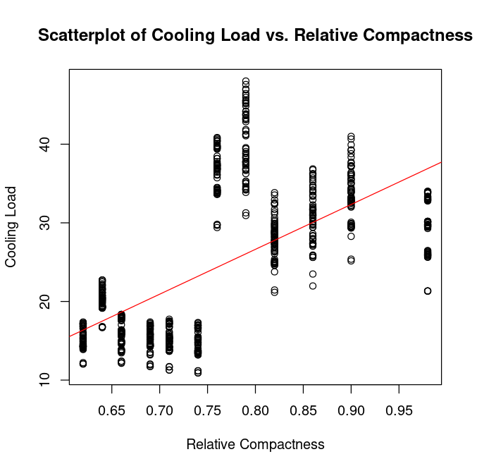

Figure 2‑6 Scatterplot of Cooling Load vs. Relative Compactness

#### Cooling Load and Overall Height

##### Hypothesis Statement

|  |  |
| --- | --- |
| H0 | There is no significant relationship between the Cooling load and the Overall Height of the building |
| H1 | There is a significant relationship between the Cooling load and the Overall Height of the building |

Table 2‑3 Cooling load and the Overall Height Hypothesis Statement

Significance level (x) = 0.05

Confidence level = 95%

##### Linear model

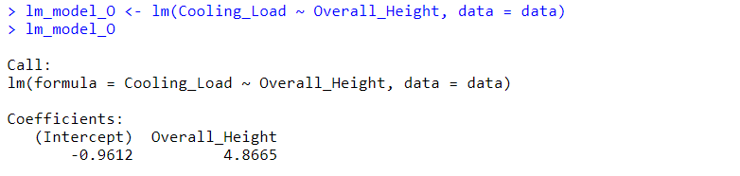

Figure 2‑7 lm () function to find coefficients.

𝑌 data$Cooling_Load = -0.96 + 4.86 𝑋 data$Overall _Height

##### Summary Statistic for lm () Function

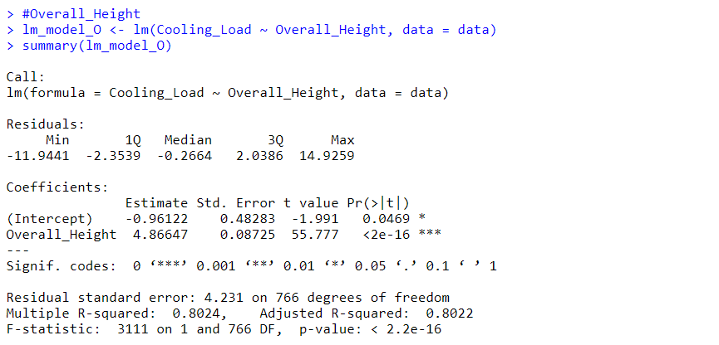

Figure 2‑8 Summary statistic function for the given lm () function

Decision: p-value = 2.2e-16 <x = 0.05> Reject H0

There is a strong and statistically significant correlation with an incredibly small p-value of 2.2e-16 for the relationship between Cooling Load and Overall Height. At a significance level of 0.05, which is commonly used in hypothesis testing, we have significant evidence to reject the null hypothesis. Therefore, there is a significant relationship between cooling load and Overall Height.

##### Scatter plot

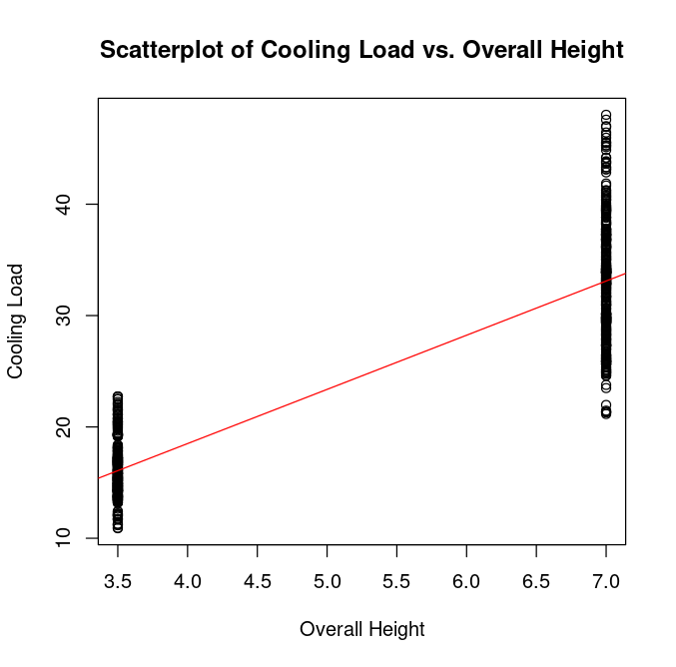

Figure 2‑9 Scatterplot of Cooling Load vs. Overall Height

#### Cooling Load and Glazing Area

##### Hypothesis Statement

|  |  |
| --- | --- |
| H0 | There is no significant relationship between the Cooling load and the Glazing Area of the building |
| H1 | There is a significant relationship between the Cooling load and the Glazing Area of the building |

Table 2‑4 Cooling load and the Glazing Area Hypothesis Statement

Significance level (x) = 0.05

Confidence level = 95%

##### Linear model

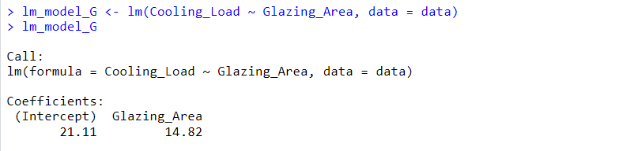

Figure 2‑10 lm () function to find coefficients.

𝑌 data$Cooling_Load = 21.11 + 14.81 𝑋 data$Glazing_Area

##### Summary Statistic for lm () Function

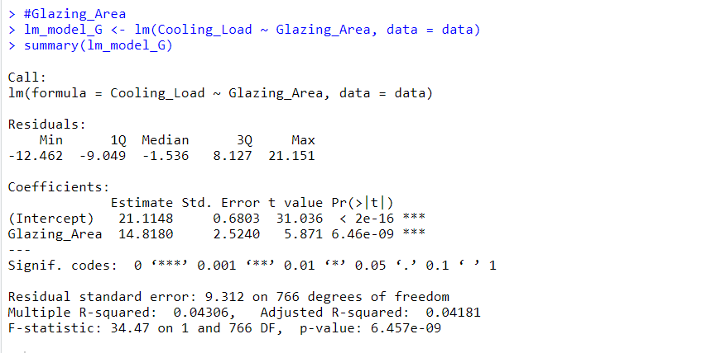

Figure 2‑11 Summary statistic function for the given lm () function

Decision: p-value = 2.2e-16 <x = 0.05> Reject H0

An incredibly small p-value of 2.2e-16 for the relationship between cooling load and glazing area has a strong and statistically significant correlation. At a significance level of 0.05, which is commonly used in hypothesis testing, we have significant evidence to reject the null hypothesis. Therefore, there is a significant relationship between cooling load and glacier area.

##### Scatter plot

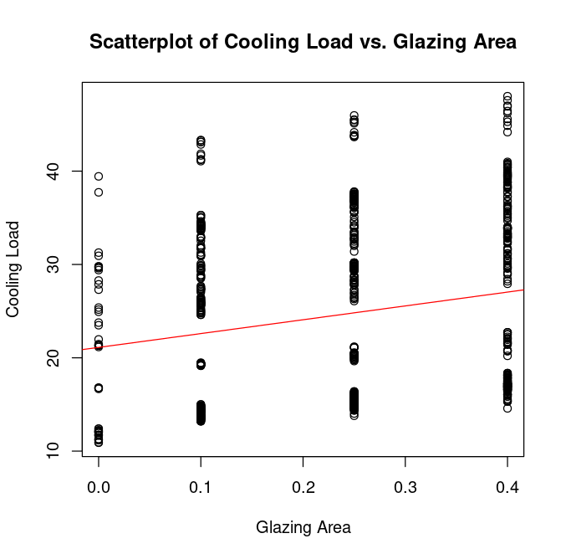

Figure 2‑12 Scatterplot of Cooling Load vs. Glazing Area

##### Full model Scatter plot

The figure below shows the scatter plot of building factors with relationships.

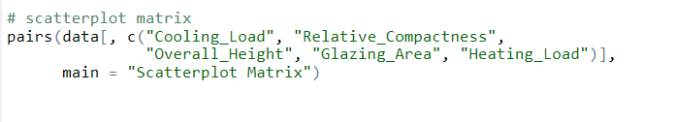

Figure 2‑13 Full model Scatter plot code

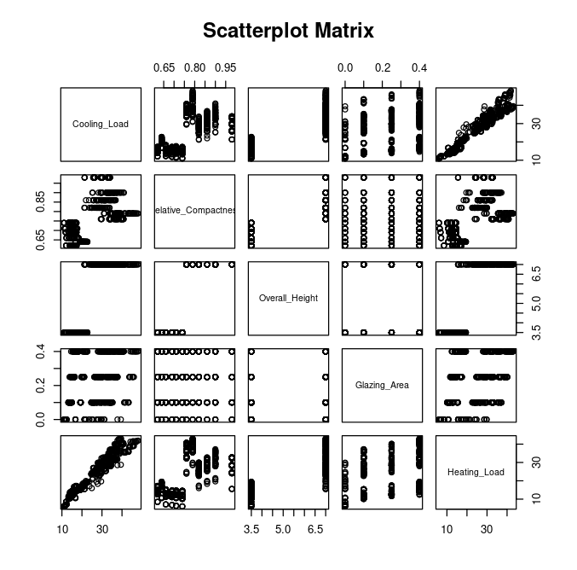

Figure 2‑14 Full model Scatter plot

# 

## Task C

In recent years, the urgent need to mitigate climate change and reduce the use of fossil fuels has emerged, and wind power has emerged as a promising and environmentally friendly alternative to generate electricity. The "Renewable Energy Development Plan 2021-2026", published by the Sri Lanka Solar Energy Authority, outlines a strategic roadmap for expanding the use of wind energy resources across the country. Accordingly, create "SLWindPowerLand_21_23.csv" data set using table 7.1: Land available for wind power data in Renewable-Energy-Resource-Development-Plan.pdf provided by Sri Lanka Sustainable Energy Authority(Rodrigo, n.d.). This CSV file is shown below.

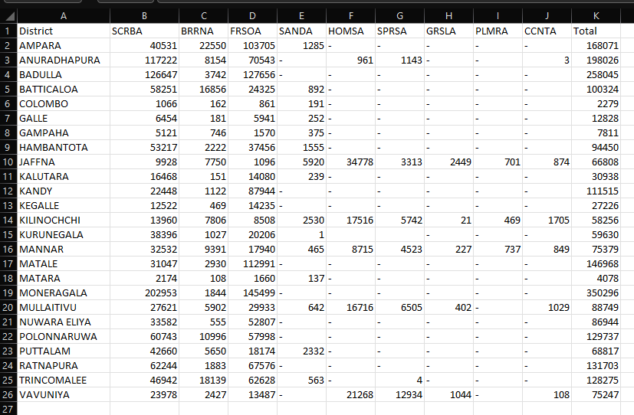

Figure 3‑1 SLWindPowerLand_21_23 Dataset

To create the "Sri Lanka Feasible Land for Wind Energy Development" map, the total size of the district, total capacity, total estimated energy is used as required data column. According to the "SLWindPowerLand_21_23.csv" file above, this map is shown in the figure below (Figure 3.2).

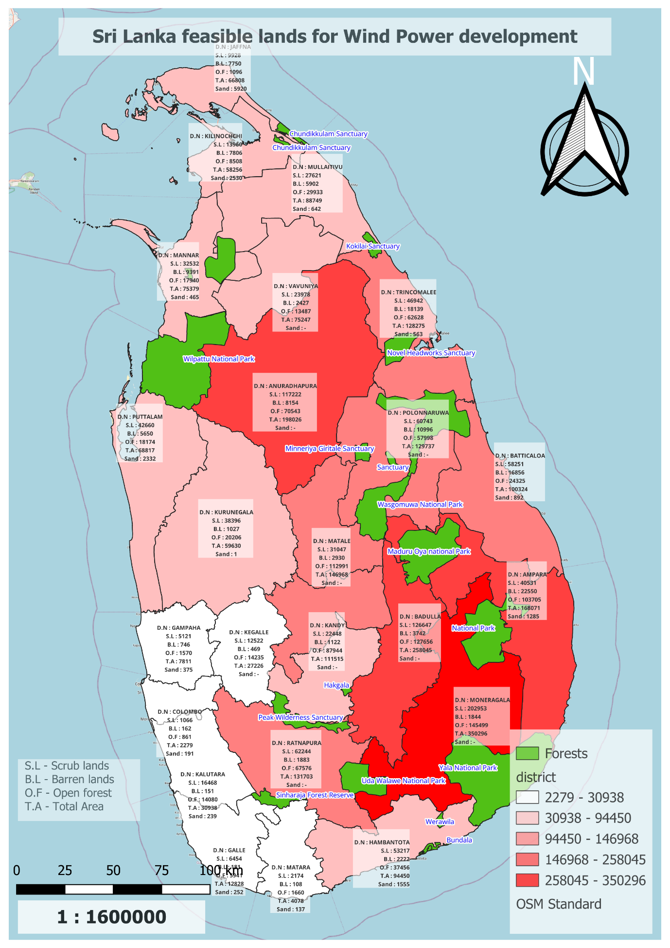

Figure 3‑2 Sri Lanka feasible lands for Wind Power development

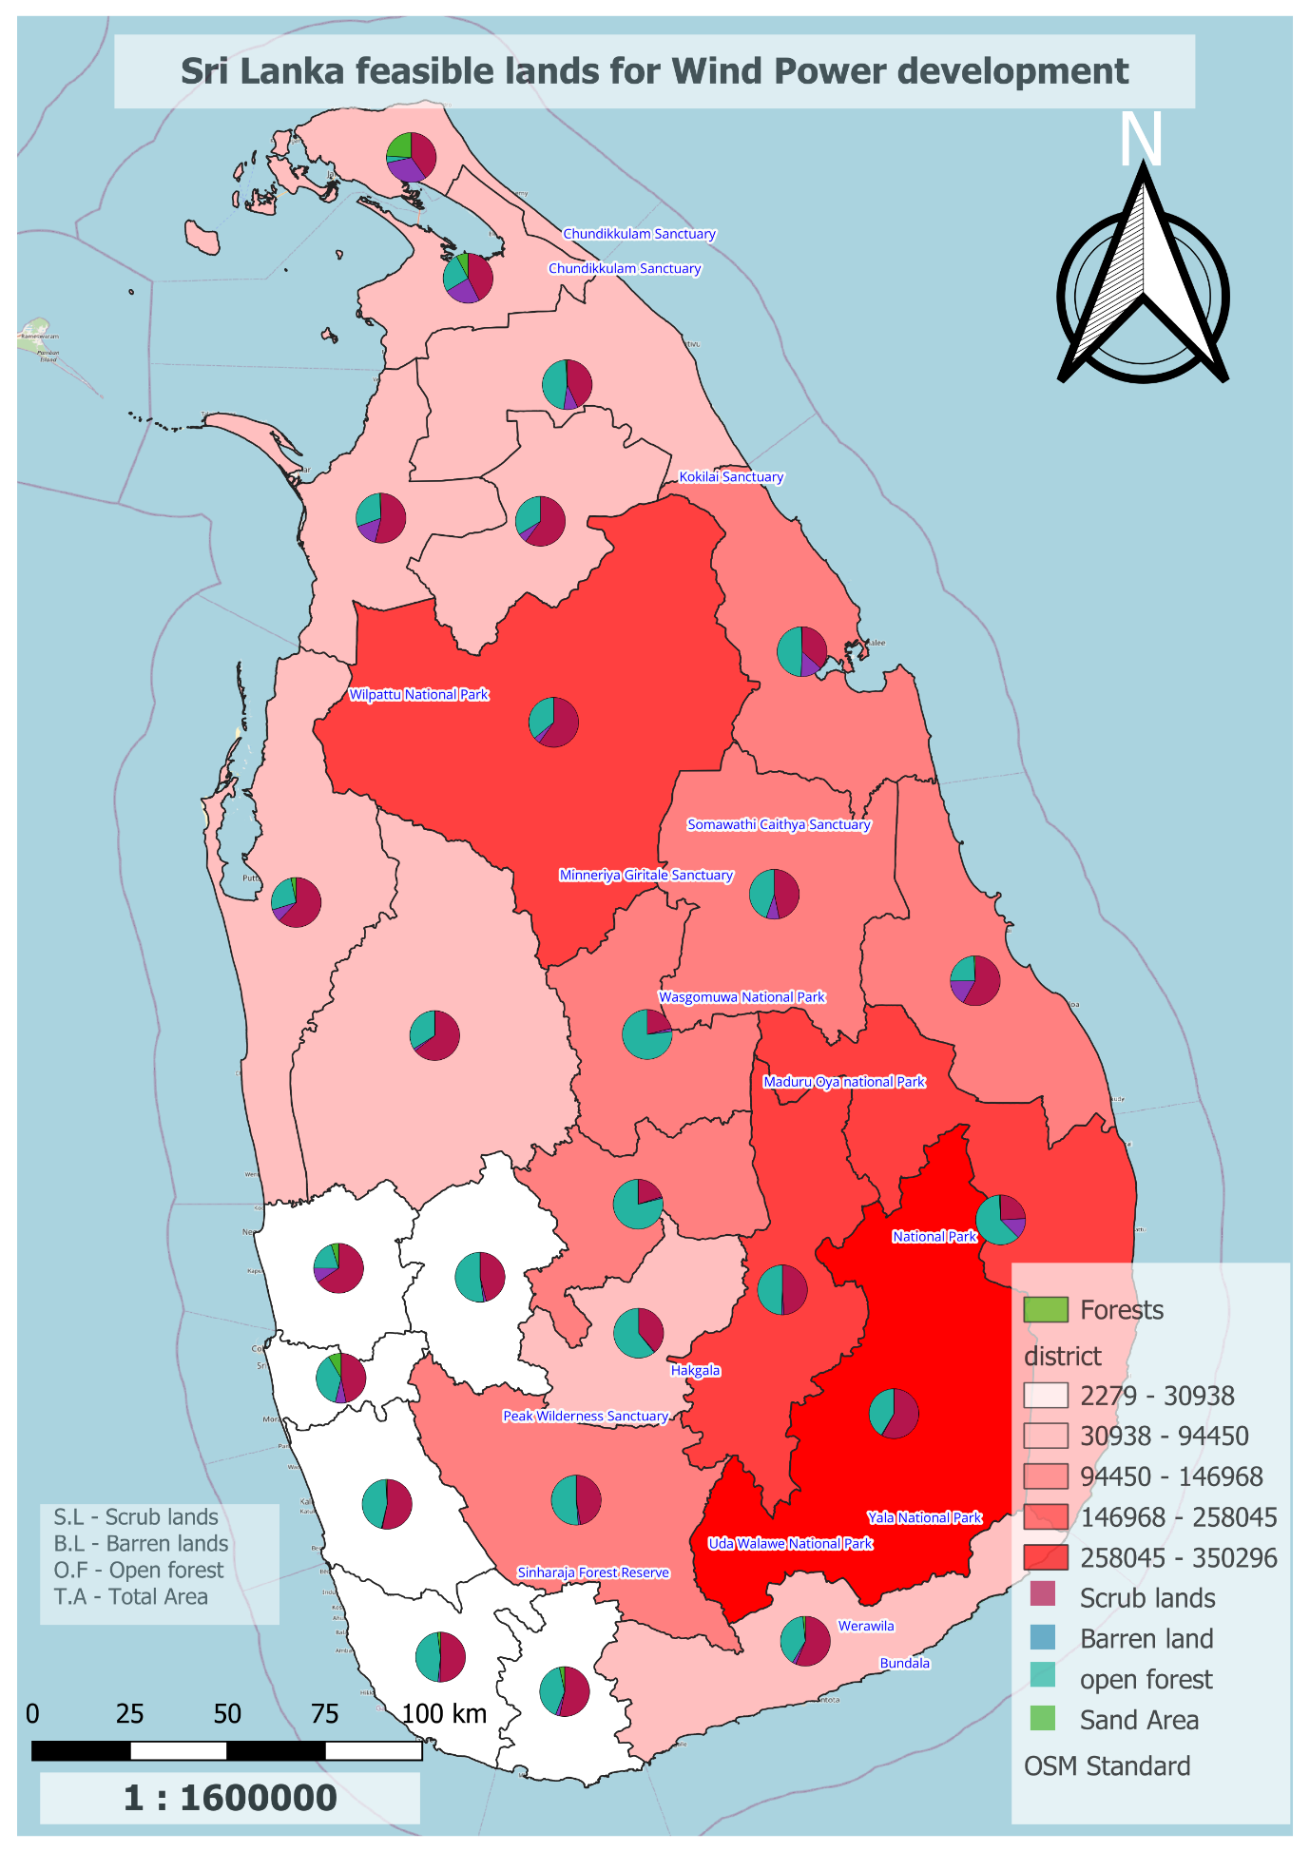

Figure 3‑3 Sri Lanka feasible lands for Wind Power development

As shown in the picture above, it has been mapped with the aim of identifying suitable areas for wind power development. Thus, district wise the total area is divided into scrub land, barren land, open forest, and sand areas. Thus, on this map, the area that represents most of the total land area is shown in dark red, and the color decreases as the geometry decreases. The area shown in white indicates the lowest area. Also, on this map all the forests of the island appear green, and these forests are denoted by name.

Figure 36-37 grouped scrubland, wasteland, open forest, and sand areas according to the map. Monaragala, Anuradhapura, Ampara, Badulla districts have the largest area but no sandy areas. The total area of these areas is more than 146968 hectares. Also, between 2279 and 30938 hectares, Gampaha, Colombo, Kalutara, Galle, Matara represent the least areas in total area. Thus, considering the Total land area according to Provinces, the following table shows.

|  |  |
| --- | --- |
| Province | Total Area (ha) |
| North Province | 364439 |
| Uva Province | 608341 |
| North Central Province | 327763 |
| East Province | 396670 |
| Western Province | 41028 |
| Central Province | 345427 |
| Southern Province | 111356 |
| Northwestern Province | 128447 |
| Sabaragamuwa Province | 158929 |

Table 3‑1 Provinces wise Total area(ha)

When compared provincially, Monaragala, Uva province belonging to Badulla shows the largest amount of land. Also, it can be understood from the above table that Eastern Province is the second largest region.

From this given data, it is not possible to determine a suitable location for wind power generation. But according to these data, Monaragala and Anuradhapura districts can be concluded as suitable areas.

For a more detailed analysis of the graphs, please consult Appendix C.

# 

## Task D

Most of the countries in the world are currently using solar power to generate renewable energy. As Sri Lanka is a country close to the equator, Sri Lanka gets constant sunlight. Maps are created according to table 7.4 of "Renewable-Energy-Resource-Development-Plan.pdf" published by Sri Lanka Renewable Energy Authority to find potential land for solar energy development. A CSV file is created using District Name, Total Area (ha), Total Capacity (MW) and Total estimated energy (GWh) to create this map. Below is an image of the relevant data set.

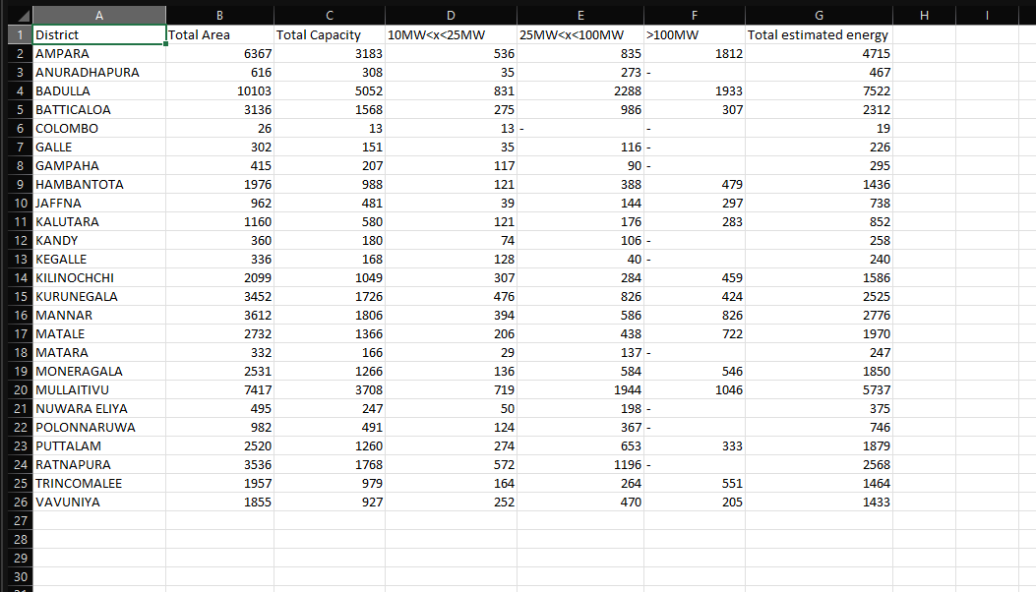

Figure 4‑1Estimated Energy dataset.

This dataset captures Sri Lanka's varied energy landscape, including changes in energy generating capacity. While some districts include a mix of smaller and medium-sized plants, some have a considerable presence of bigger energy-producing facilities. The data shows each district's contribution to the nation's overall energy supply as well as its potential for energy production.

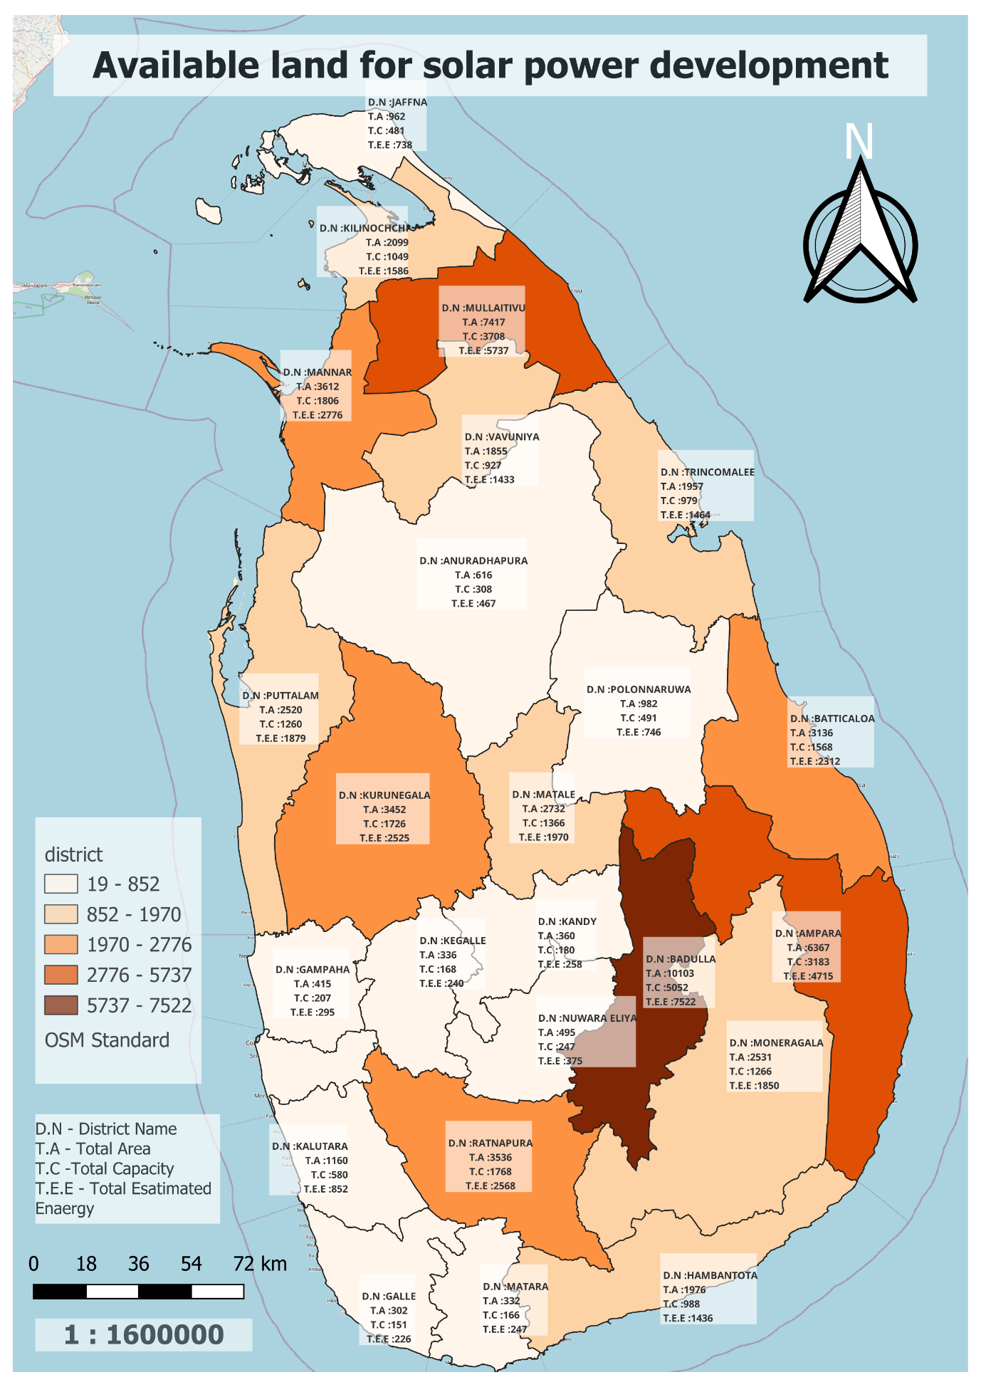

Figure 4‑2 Available land for solar power development

Shown above (Figure 4.2) is the map of land available for solar energy development. As shown in this map, the area of highest total estimated energy is shown in dark brown. Also, the bold color represents the range of total estimated energy between 2776 and 5737. Areas with low total estimated energy are represented in white. This map is described below.

By studying this map, it is identified that most of the estimated total energy can be generated from Badulla district. Its total area is about 10103 hectares. The total capacity of this district is 5052 MW. According to the data presented by the Sri Lanka Renewable Energy Authority, the estimated total energy in this area is identified as 7522GWh. According to this map the total estimated energy in the range of 277GWh6 and 5737GWh as TEE in Ampara and Mullaitivu districts is 4715GWh and 5737GWh. Thus, the second highest TEE value is shown in Mullaitivu district. Also, the TEE value of Mannar, Kurunegala, Batticaloa, and Ratnapura districts are in the range of 1970GWh and 2776GWh. Gampaha, Kalutara, Galle, Kegalle, Kandy, Nuwara Eliya, Anuradhapura and Jaffna districts are the districts with the lowest estimated energy. Its TEE value is less than 852GWh areas.

|  |  |
| --- | --- |
| Province | Total Estimated Energy (GWh) |
| North Province | 12270 |
| Uva Province | 9372 |
| North Central Province | 1213 |
| East Province | 8491 |
| Western Province | 1166 |
| Central Province | 2603 |
| Southern Province | 1909 |
| Northwestern Province | 4404 |
| Sabaragamuwa Province | 2808 |

Table 4‑1Province wise Total estimated energy

Northern province can be considered as the highest TEE by province. It is shown as 12270GWh in the above table. The Western Province can be introduced as the province where the minimum amount of GWh can be obtained. Thus, Badulla district is the area with the highest TEE availability, which is different from other provinces. Understanding these processes can provide insight into Sri Lanka's energy planning and distribution systems, and support decision-making to ensure a reliable and sustainable energy supply across many sectors of the country. For a more detailed analysis of the graphs, please consult Appendix D.

# 

## Task E

At a time when sustainable energy solutions are critical, using solar energy is still a realistic option. Solar power plants and their suburbs are shown in Google image digitized. Thus, with the help of QGIS(Kranjac et al., 2018), the map should include the solar plants, buildings, roads, trees and forests. Also, coordinate reference system as WGS84-EPSG4326 is used for map development. Thus, the image created with the help of QGIS is provided below.

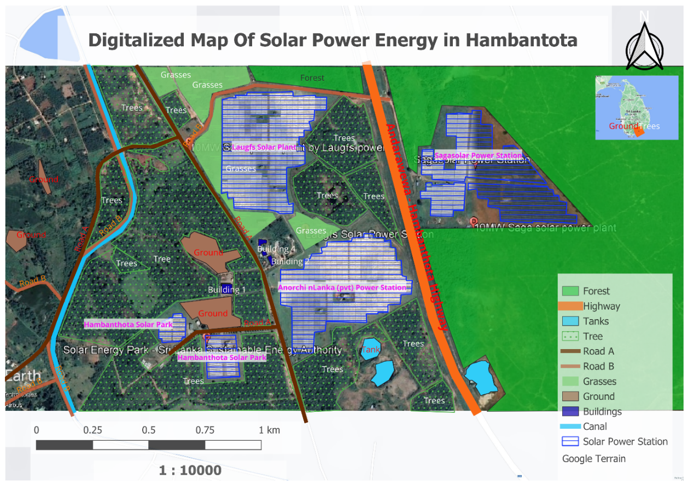

Figure 5‑1 Digitalized Map Of Solar Power Energy in Hambantota

Solar energy, especially as a renewable energy source, provides a critical solution to the island's energy challenges. This map uses Google Earth, Google Maps, and QGIS plugins to digitize a solar plant and its surroundings. Accordingly, separate shapefiles are created for the solar plant, buildings, roads, trees, and ponds in this map. This map aims to assess the potential of solar energy to solve the island's energy problems. And according to my map, Andarawawa to Hambantota highway is depicted in orange colour. Also, Solar power station has been built on both sides of this highway. Talking about solar plant, Laughs solar plants, Anorchi Lanka, Sagasolr, and Hambantota solar park have created power station. From the direction shown in this map, the forest appears in green colour from the east. Studying this map has shown many tree locations. Also, canal and Tanks are represented in blue colour. And the brown colour represents the ground area.

According to this map, it is suitable for the construction of solar power station in Sri Lanka. Also, there are rural areas where electricity cannot be provided. Solar power station can be built as a solution to those areas. Also, at present, hydroelectric power plants are used to supply electricity to Sri Lanka, but due to the lack of rainfall, it is difficult to supply electricity. As a solution to that, by deploying solar power stations nationwide, the Sri Lanka Sustainable Energy Authority will not have to face difficult situations.

For a more detailed analysis of the graphs, please consult Appendix E.

# 

## Task F

In this chapter a detailed analysis is done using the thematic map according to the data file provided by Sri Lanka Sustainable Energy Authority. To accomplish this task, a table named SLGOVSCHOOLS.2019 was created under this database and the required data was entered. Table: 5-03 provided in the file "Disaggregation-of-Petroluem-Fuel-Use-2021-May-29.PDF" was used to create this data file. Accordingly, in the CSV file prepared previously, District Name, No of Sheds, Mean and SD of Gasoline, Mean and SD of Diesel I saved the data as SLPetrolium-2023. A screenshot of this file (figure 6.1) is shown. According to this data file, a PostgreSQL database named "SLPetrolium-2023" was created using PgAdmin software.

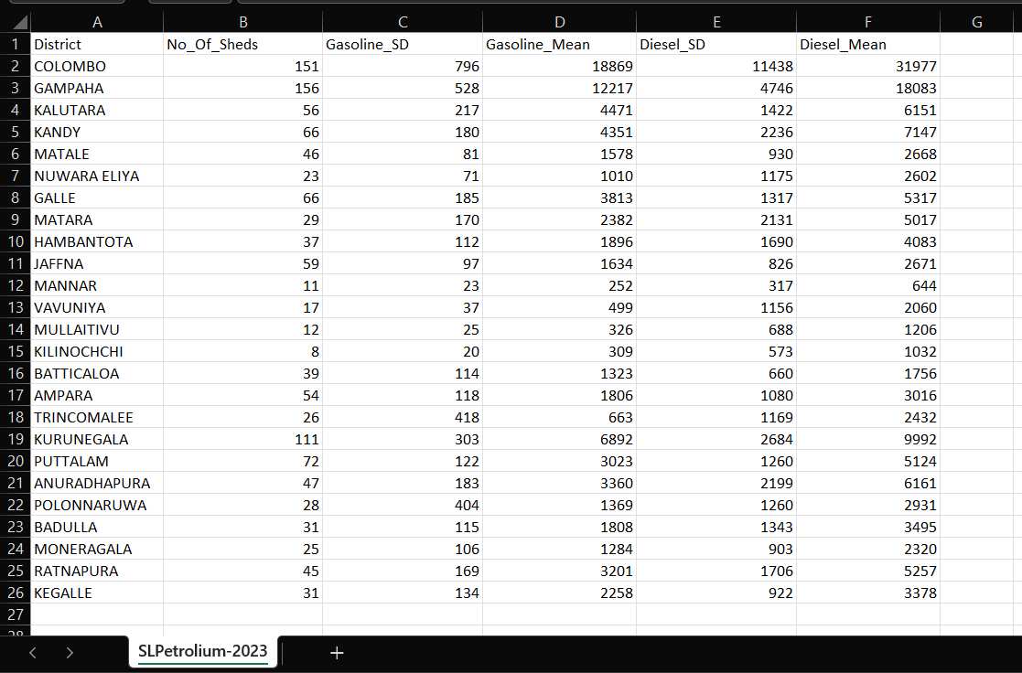

Figure 6‑1 Number of sheds, Gasoline, and diesel dataset

Below is the thematic map showing the number of sheds according to the data set added to PostgreSQL named "SLPetrolium-2023".

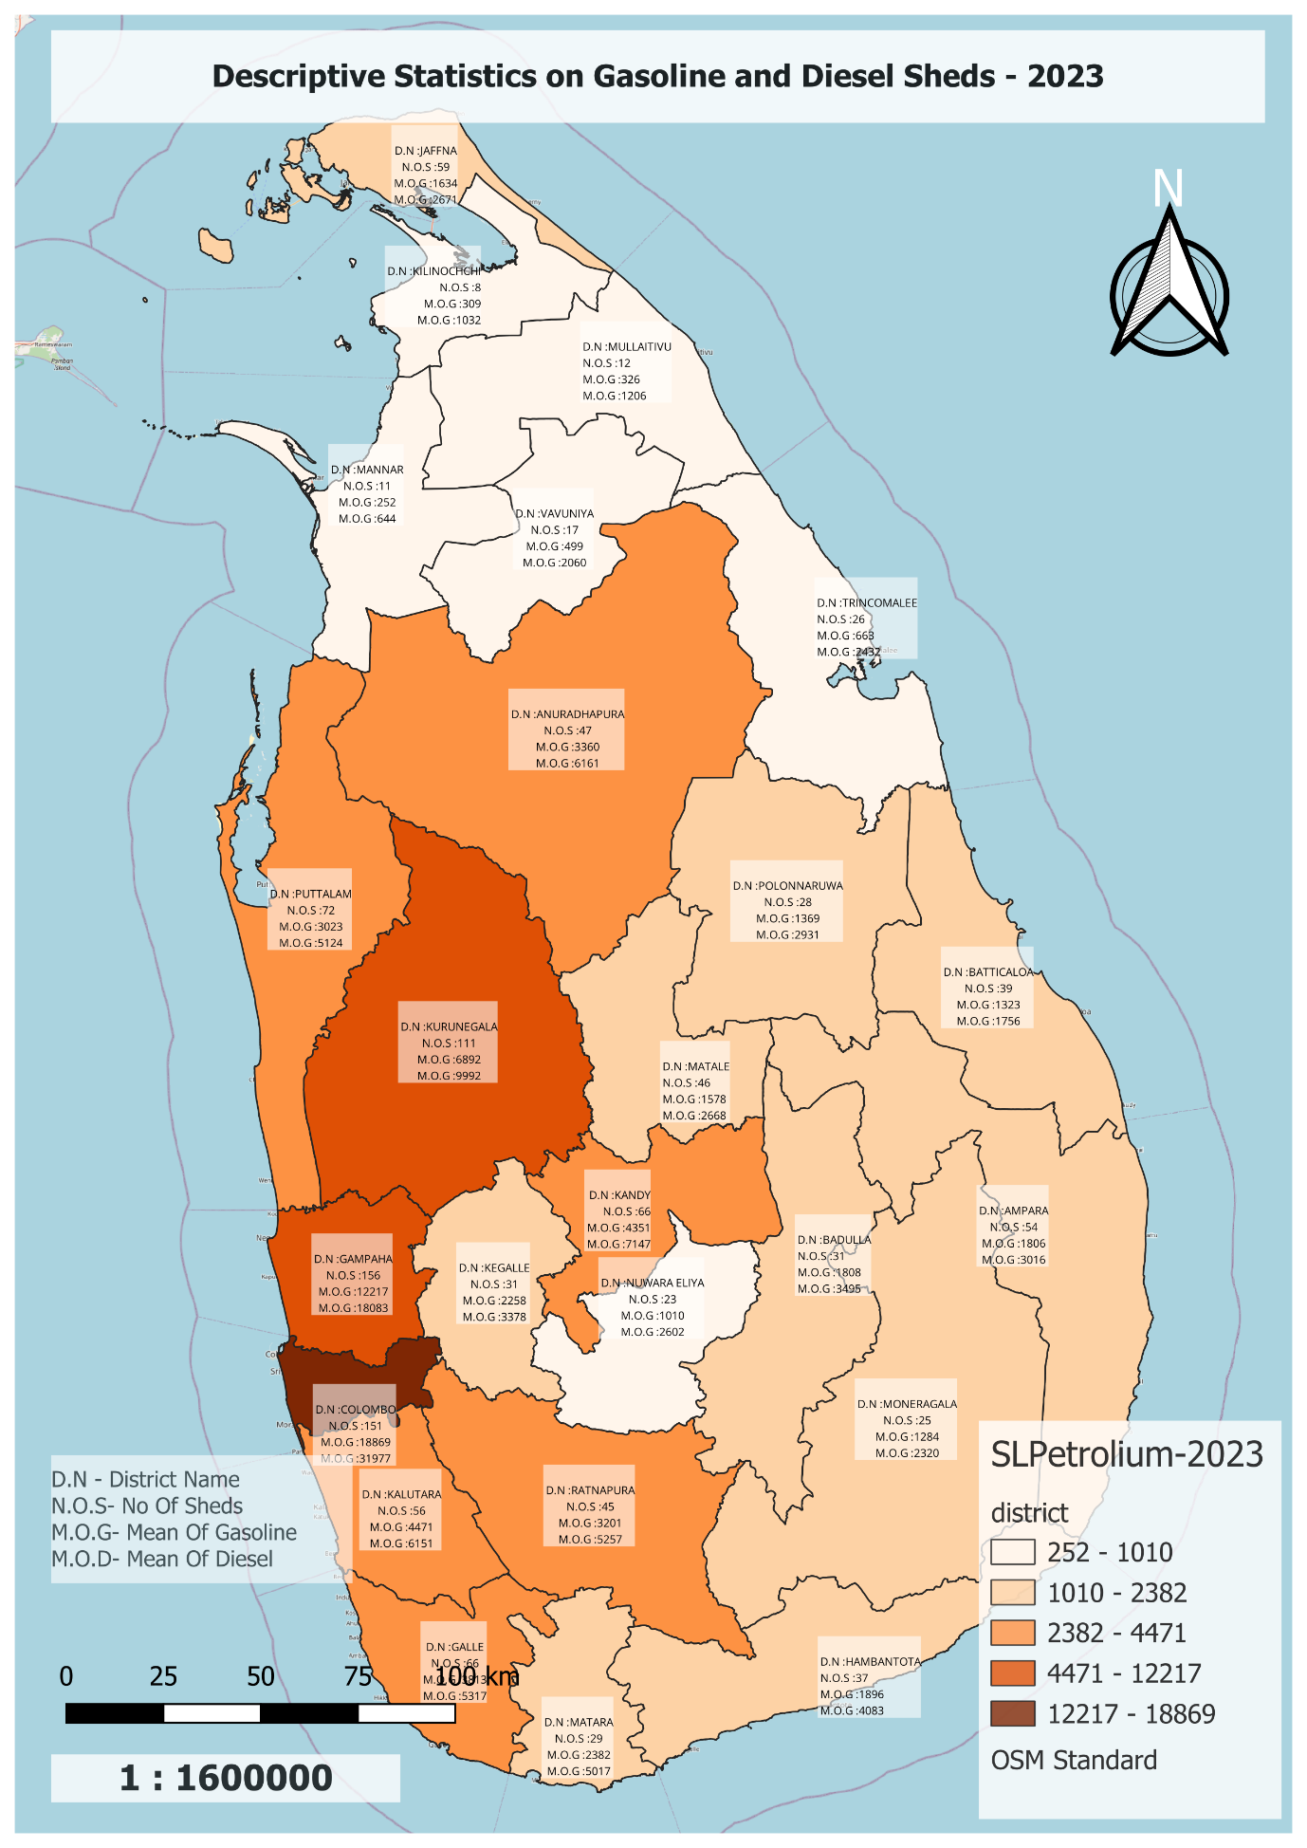

Figure 6‑2 Descriptive Statistics on Gasoline and Diesel Sheds - 2023

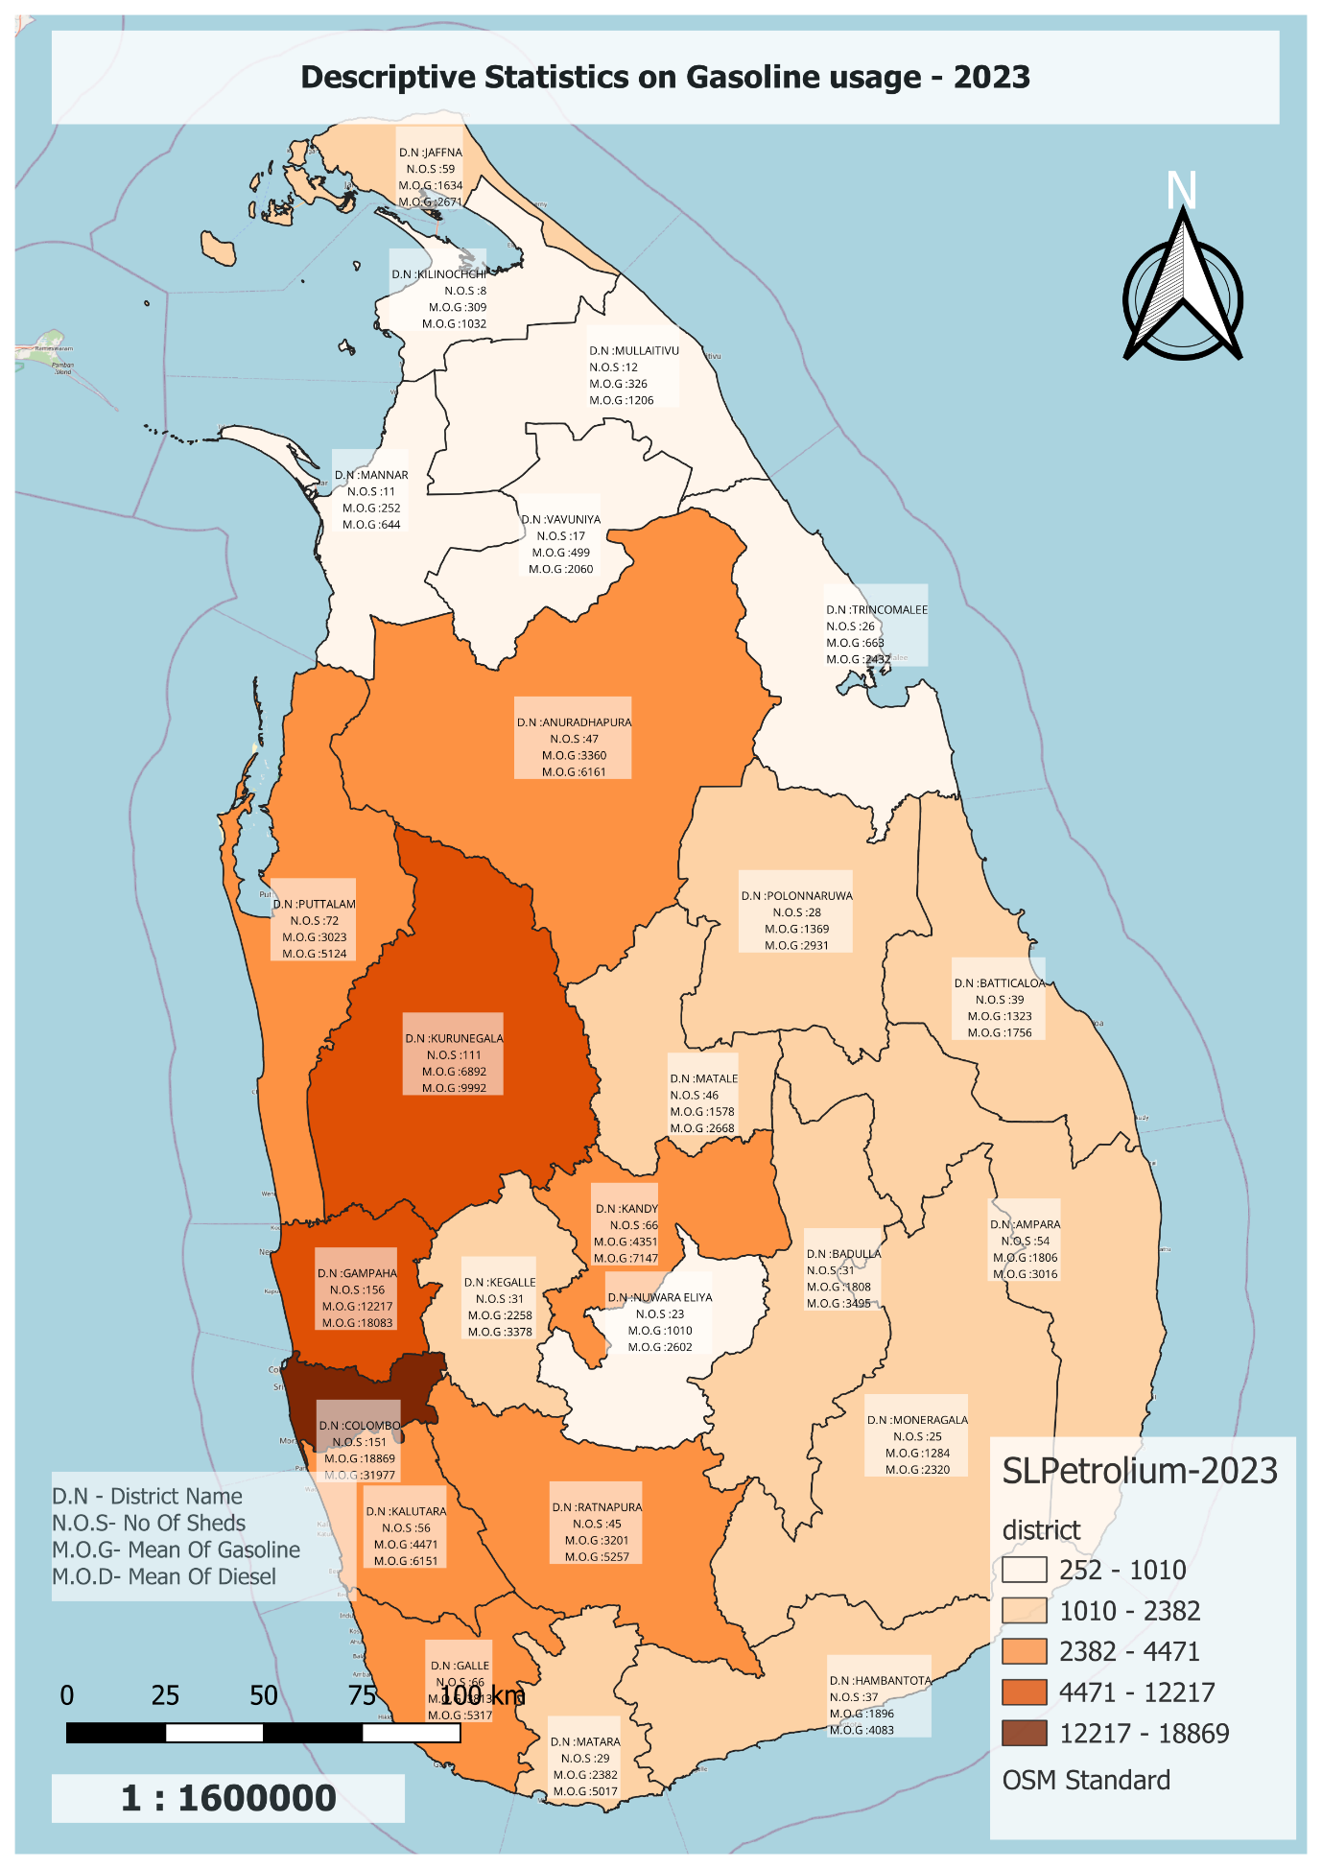

Figure 6‑3 Descriptive Statistics on Gasoline usage - 2023

The above thematic map illustrates information about the District Name, No of Sheds, Mean and SD of Gasoline, and Mean and SD of Diesel. And by studying this map, the Gampaha district has the highest number of sheds. It is represented by N.O.S- 156. And 111 and 156 ranges include Gampaha as well as Colombo district. It has 151 sheds. Thus the "Descriptive Statistics on Gasoline Usage- 2023" map shows that Colombo Districts have the highest Mean of Gasoline. From this it can be concluded that the consumption of Gasoline and Diesel is higher in Colombo districts compared to Gampaha districts. Also, considering the use of Gasoline, Kurunegala has the third highest use and shows 9992 as the mean of its use value.

However, the largest number of sheds in the Northern Province is in the Jaffna district. It has 59 sheds. Compared to other Northern Province districts (Mutative, Kilinochchi, Vavuniya and Mannar) the number of sheds in these districts is very low and their values are 12, 8, 17, 11 respectively. And a look at the petrol consumption map shows a huge lack of work for the districts in the western provinces.

Using this database and map, stakeholders, decision makers and energy planners can gain important insights into regional patterns of petroleum use across districts. These data appear to be critical for developing focused initiatives to improve sustainable energy use and resource allocation.

For a more detailed analysis of the graphs, please consult Appendix F.

# 

## Task G

Sri Lanka, a tropical island in the Indian Ocean, is gradually recognizing the importance of sustainable energy sources for its development. As the world grapples with environmental challenges, the Sri Lanka Renewable Energy Authority strategically identifies viable sites for renewable energy generation across the island. It creates a map. Also, information like location labels, district names, latitudes, and longitude are displayed on the map. Google Earth Pro is used to set the latitude and longitude of the correct location. This obtained location is saved as KMZ File. This obtained KMZ file is used to visualize the map using QGIS. As shown in the map below (Figure 7.1), the location where renewable energy such as Solar, Wind, and Biomass can be established in Sri Lanka is shown.

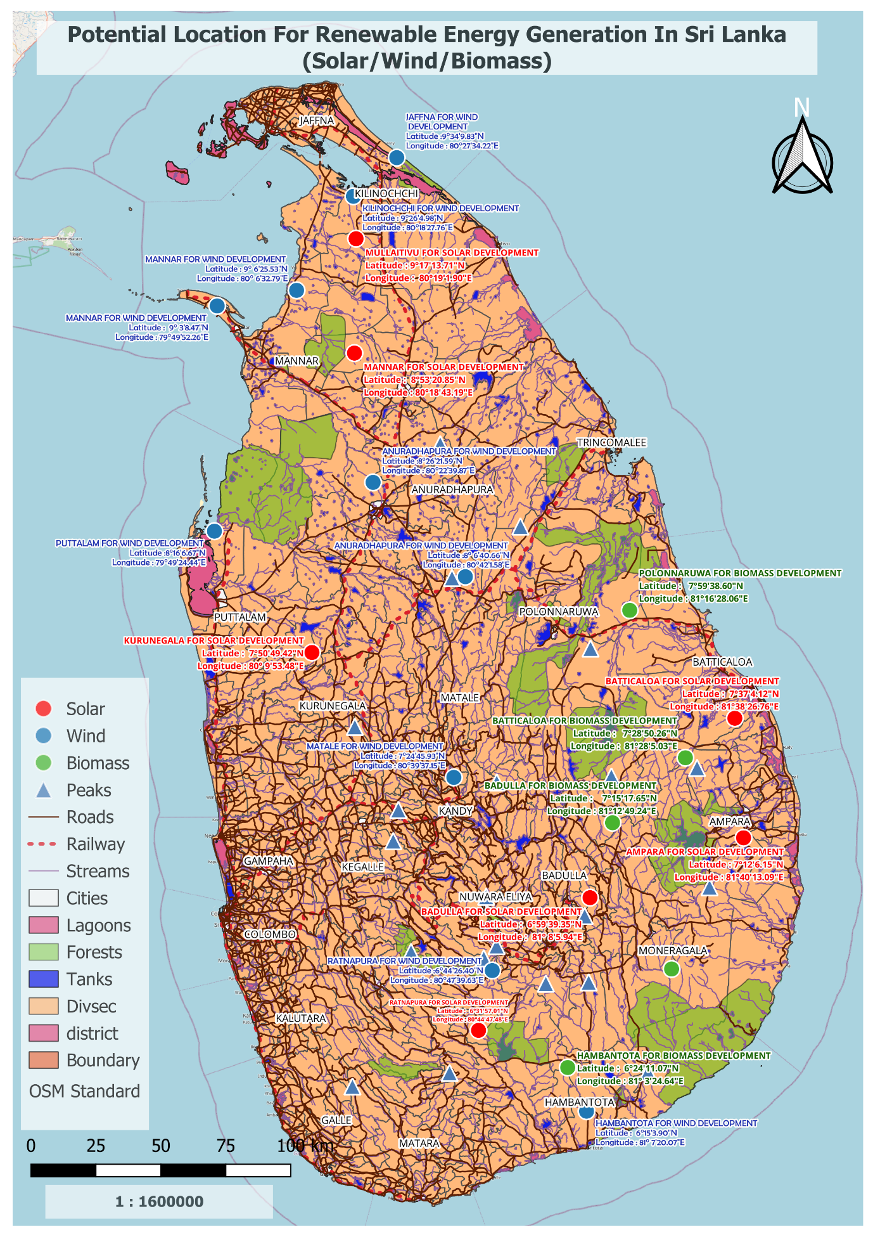

Figure 7‑1 Potential Location For Renewable Energy Generation In Sri Lanka(solar, wind, Biomass)

The above map shows the location for the renewable energy plant and the points used in red mark the suitable locations for the construction of the solar plant. Blue points indicate areas suitable for wind power development and green points indicate areas suitable for biofuel production. The light green areas on this map are obviously forested areas.

As shown in the maps in the above Tasks, suitable areas for Solar and Wind power station development in Sri Lanka have been shown. Also, the data in the PDF file provided by the Sri Lanka Sustainable Energy Authority has been studied and appropriate areas have been mapped according to that map. As previously mentioned, Mannar, Mullaitivu, Kurunegala, Batticaloa, Badulla, and Ratnapura districts have been shown in red as the areas to develop the Solar project, and the Latitude and Longitude information related to those districts has been visualized. While selecting the location for solar project development, the district has been studied using Google Earth Pro and vacant land areas and government lands have been selected in that area. Also, two locations have been provided from Hambantota, Ratnapura, Mathele, Puttalam, Jaffna and Mannar and Anuradhapura districts as areas for the Wind power development project. In selecting these land areas, the factors of environmental impact, infrastructure, nearby schools, and minimum areas of hospitals were carefully considered. Also, Hambantota, Monaragala, Badulla, Batticaloa, and Polonnaruwa are clearly shown on the district map as suitable areas for Biomass projects. Also, Latitude and Longitude information has been visualized in the areas suitable for construction. The map below (Figure 7.2, Figure 7.3, Figure 7.4) shows separately Solar, Wind, and Biomass.

Ultimately, this mapping will enable the Renewable Energy Authority to select viable sites and increase renewable energy generation in Sri Lanka.

For a more detailed analysis of the graphs, please consult Appendix G.

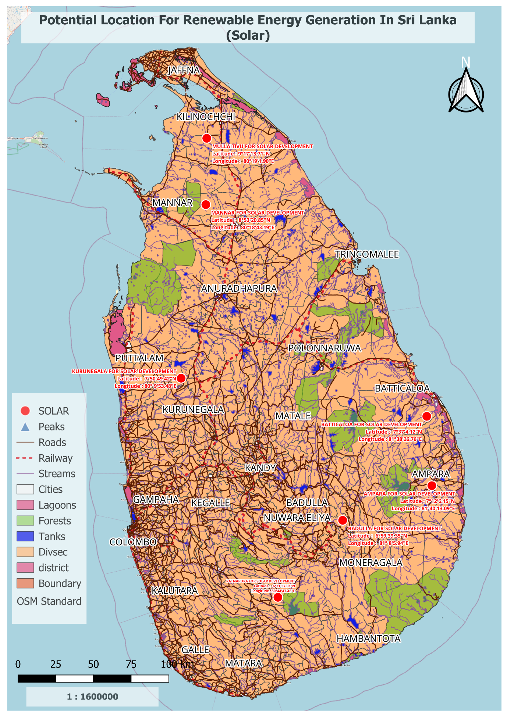

Figure 7‑2 Potential Location For Renewable Energy Generation In Sri Lanka (solar)

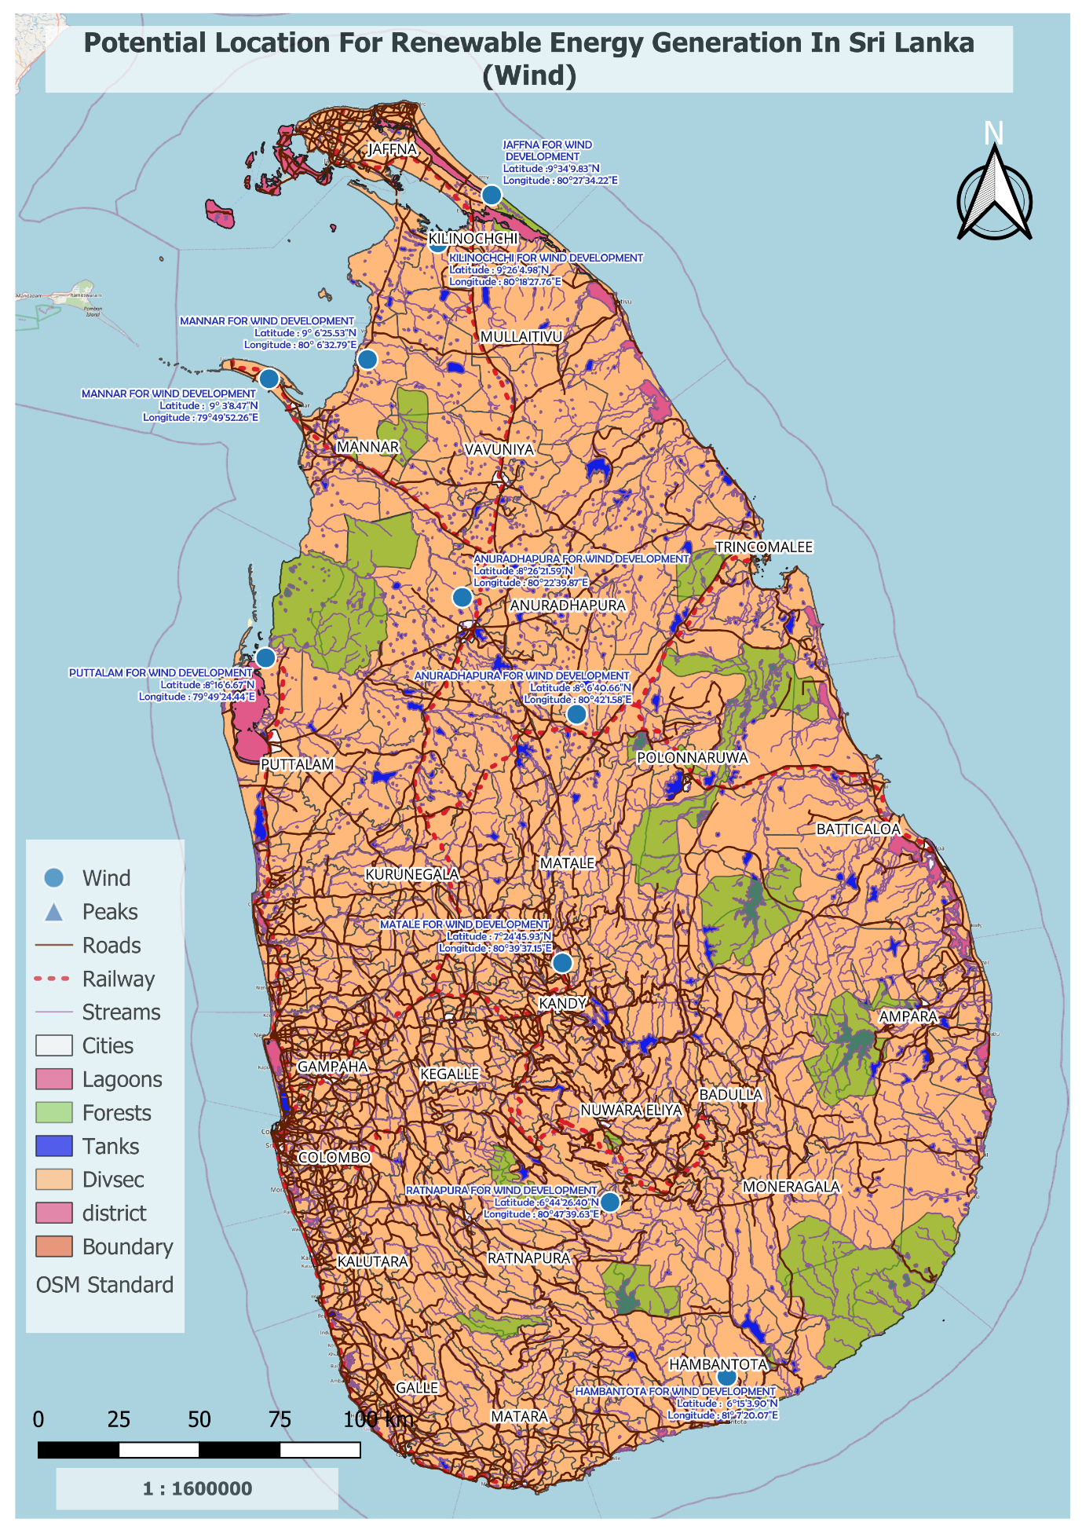

Figure 7‑3 Potential Location For Renewable Energy Generation In Sri Lanka (Wind)

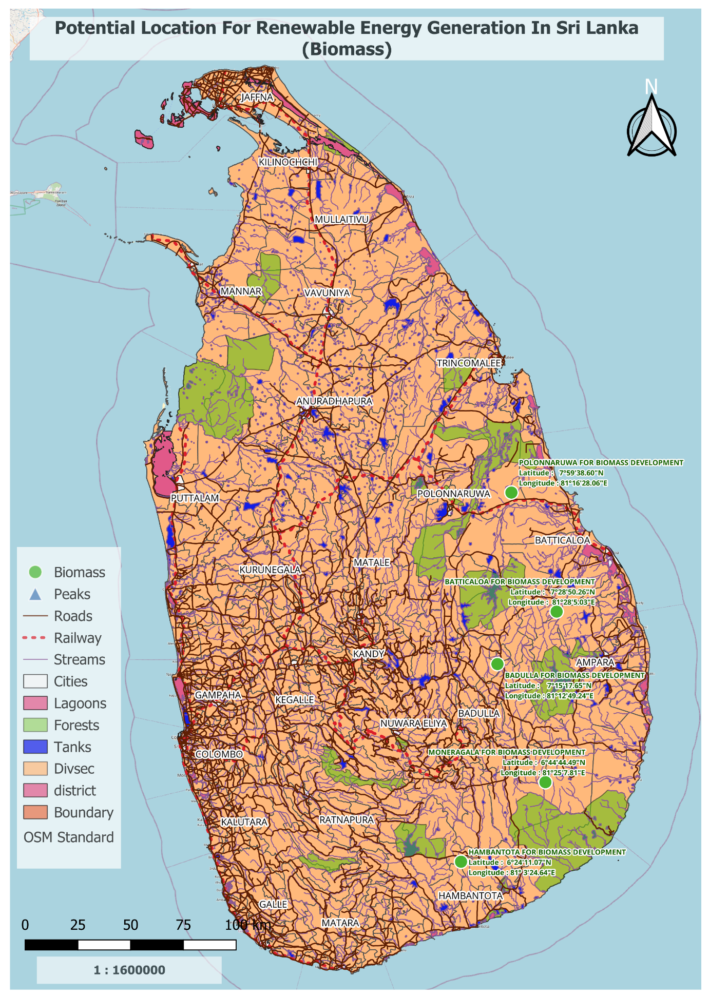

Figure 7‑4 Potential Location for Renewable Energy Generation In Sri Lanka (Biomass)

# 

## Task H

Described in this chapter, a map has been created to locate suitable land for the new development of a regional research center on renewable energy in Kandy. The given shape file has been used to create this map. Also, 3 feasible areas are used to create this map and these areas are 500 meters from Uruwala Primary School, 600 meters from Industrial Development, and 700 meters from Jayathilaka Hall respectively.

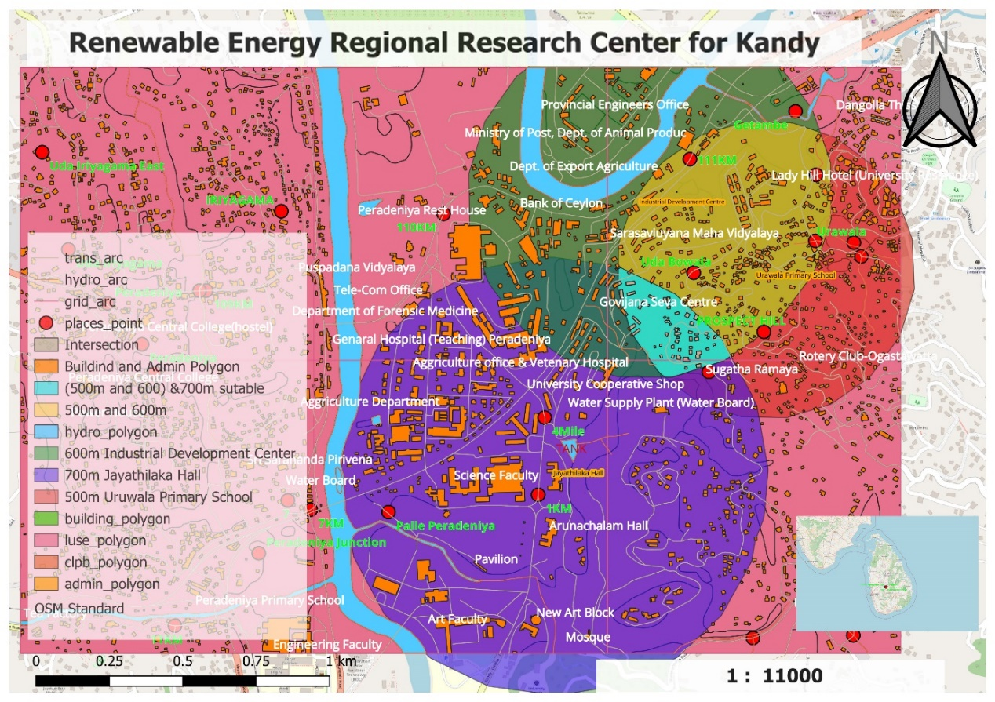

Figure 8‑1 Renewable Energy Regional Research Centre for Kandy

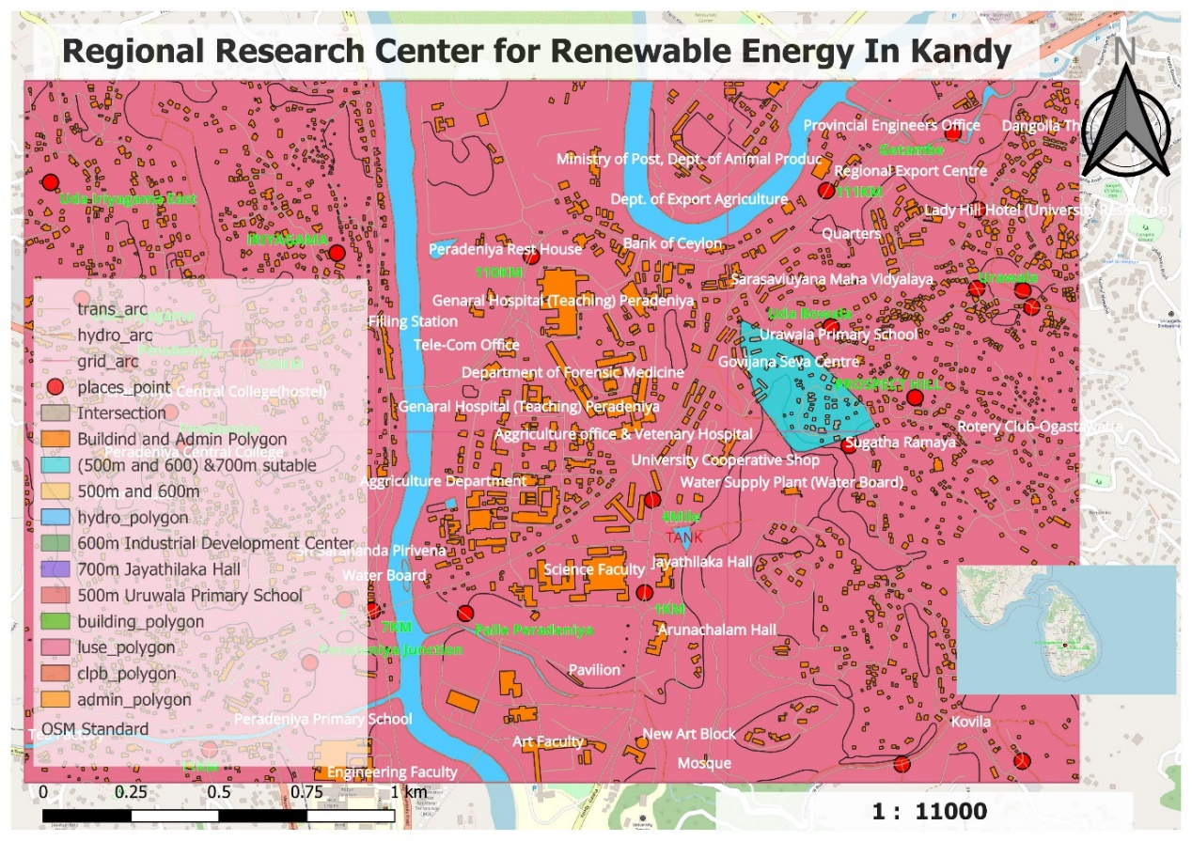

Figure 8‑2 Renewable Energy Regional Research canter for Kandy (sutable area)

|  |  |
| --- | --- |
| Renewable Energy Regional Research Center for Kandy | |
| Total number of buildings situated within the suitability area at present. | 55 |
| Total land area occupied by the buildings within the suitability area. | 73421 m2 |
| Total suitable land area | 7928 m2 |

Figure 8‑3 Total number of buildings, Total land area, Suitable land area

As shown in the picture above, three locations were used to design the intersection, Uruwala Primary School, Industrial Development Center and Jayathilake Hall. The red circle on the map is 500 meters from Uruwala Primary School, the green circle is 600 meters from Industrial Development Center and the blue circle is 700 meters from Jayathilaka Hall. Thus the part shown in sky blue is identified as the suitable part to create the "Regional Research Center for Renewable Energy". Agricultural Service Center is located around this selected area. To the right of this selected section is Sugatharamaya. The block chosen to create the Regional Research Center for Renewable Energy spans 55 buildings. Also, the total area occupied by buildings in the appropriate area is 73421 square meters. The total suitable area is 7928 square meters.

Ultimately, the creation of the Regional Research Center for Renewable Energy represents a deliberate move to support regional innovation, education and sustainable development. The research center has the potential to become a major hub for renewable energy research, leveraging the advantages of the selected site and addressing potential issues, significantly aiding efforts to transform the island's energy sector and further its sustainability goals.

For a more detailed analysis of the graphs, please consult Appendix H.

## Conclusion

To sum up, to address urgent power-generating concerns and fulfil rising energy demands, the Ministry of Power and Renewable Energy has launched a comprehensive research initiative. Enhancing energy efficiency in building cooling systems has been a major area of attention. This is important since these systems play a significant role in the use of electricity in the residential and commercial sectors.

The project has adopted a diverse strategy and is using technologies including R, R-studio, QGIS, and PostgreSQL. Building cooling and structural characteristics may be correlated, according to a preliminary examination of the "energy_efficiency_data.csv" dataset and its supporting data dictionary. These realizations are essential for later stages, especially for creating accurate statistical models that capture the complex interactions between cooling systems and associated structural elements.

Using QGIS and open-layer plugins, the team has further gone into geospatial analysis to provide an improved informative map. This map shows potential areas for solar power plant development while considering relevant aspects such as existing buildings, roads, and vegetation. This project offers useful insights into how solar energy might be used to alleviate Sri Lanka's energy sector's difficulties.

An important project in and of itself has been the creation of the PostgreSQL geographic database "SLPetrolium-2023". Important data on the district level consumption of petrol and diesel is included in this database. The spread of petroleum product use may be clearly shown using thematic maps created from this source. Additionally, by identifying prospective locations for renewable energy generation, the initiative has matched its objectives with the vision of the Sri Lanka Sustainable Energy Authority.

In conclusion, the Ministry's integrated strategy for addressing energy concerns combines data-driven research, cutting-edge technology, and a keen understanding of local subtleties. Significant contributions to Sri Lanka's sustainable energy future are anticipated, along with initiatives for effective power generation, decreased consumption, and increased dependence on renewable energy sources.

## Gantt Chart

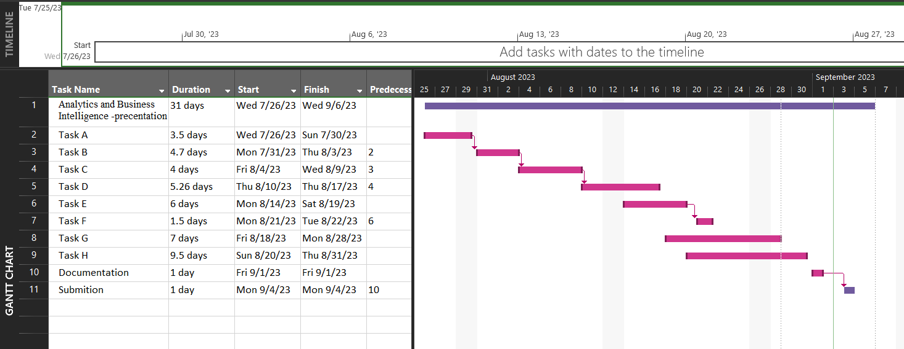

## Reference

Ansari, S. and Nassif, A.B., 2022. A Comprehensive Study of Regression Analysis and the Existing Techniques. In: 2022 Advances in Science and Engineering Technology International Conferences (ASET). 2022 Advances in Science and Engineering Technology International Conferences (ASET). pp.1–10. https://doi.org/10.1109/ASET53988.2022.9734973.

Kranjac, M., Sikimić, U., Salom, J., Tomic, S. and Bulajić, S., 2018. Visualization of smart specialisation process using QGIS tools. In: 2018 41st International Convention on Information and Communication Technology, Electronics and Microelectronics (MIPRO). 2018 41st International Convention on Information and Communication Technology, Electronics and Microelectronics (MIPRO). pp.1444–1448. https://doi.org/10.23919/MIPRO.2018.8400260.

Millán-Martínez, P. and Oller, R., 2020. A Graphical EDA Tool with ggplot2: brinton. The R Journal, 12(2), p.311. https://doi.org/10.32614/RJ-2021-018.

Rodrigo, D.A., n.d. Renewable Energy Resource Development Plan 2021-2026.

## Appendix

**Appendix C**

* Joined dataset.

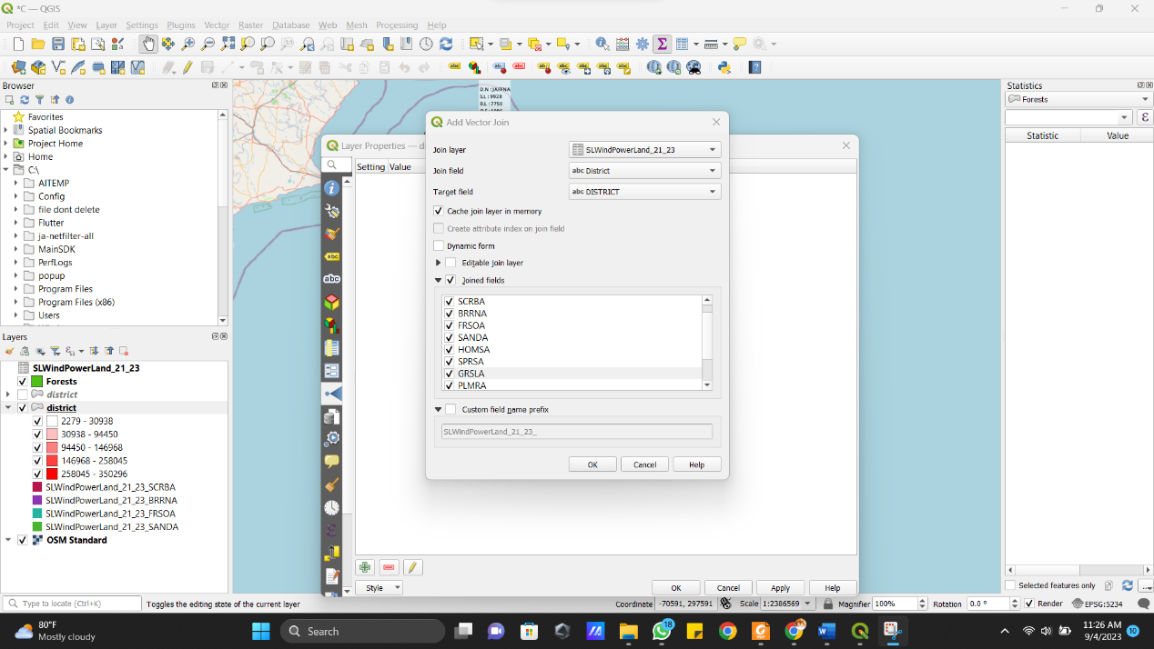

* Labeling map

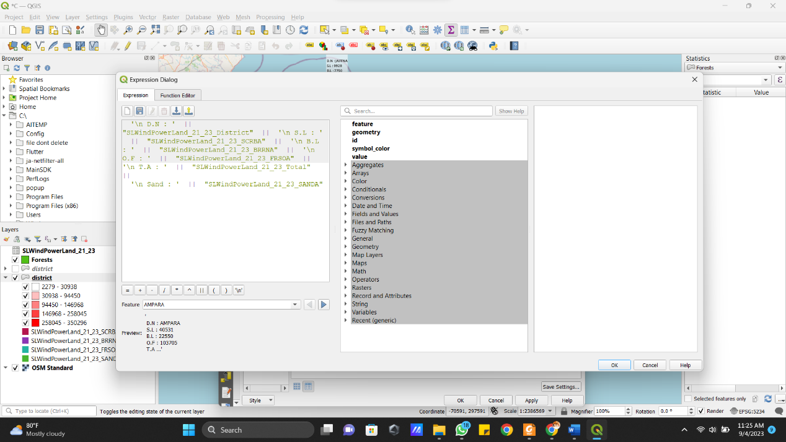

* Visualize map using total area.

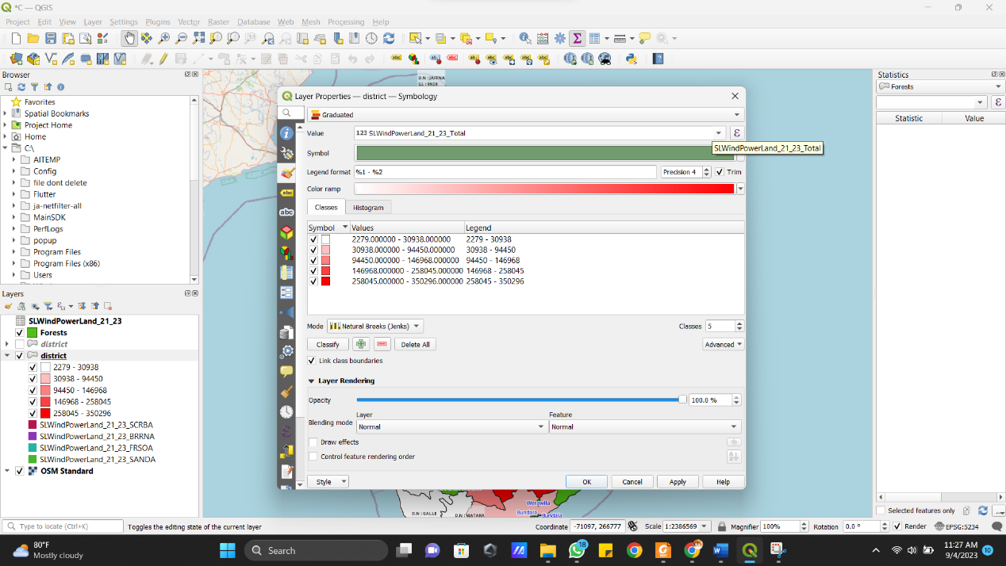

* Print view

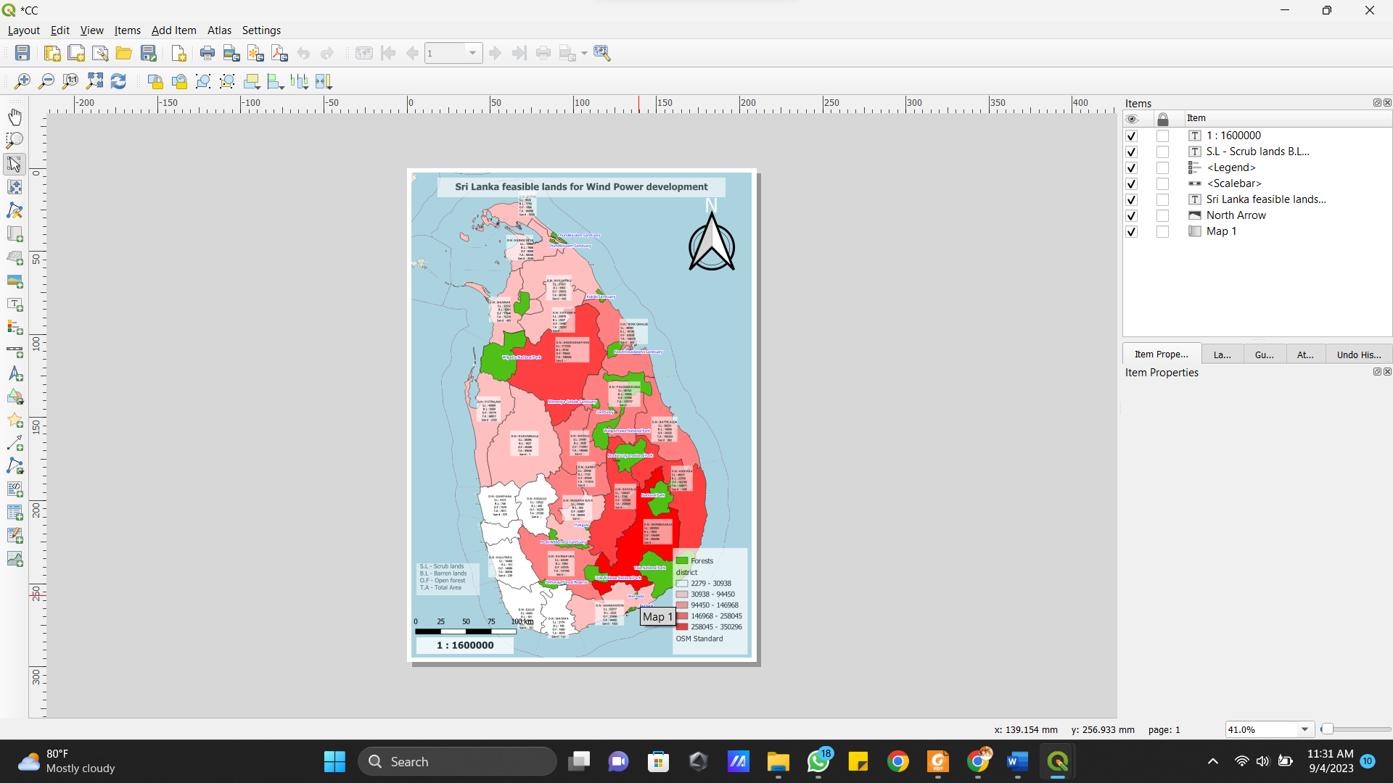

**Appendix D**

* Select OSM Map

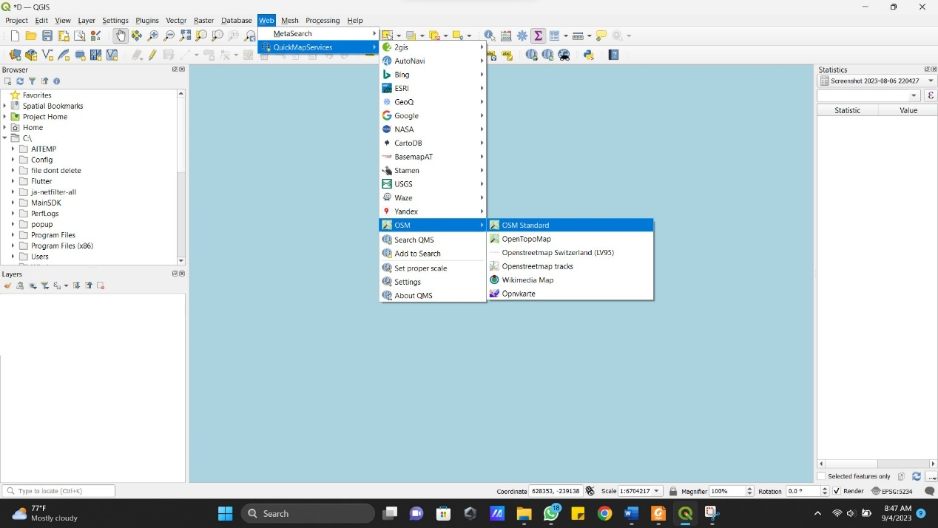

* Jointed Dataset

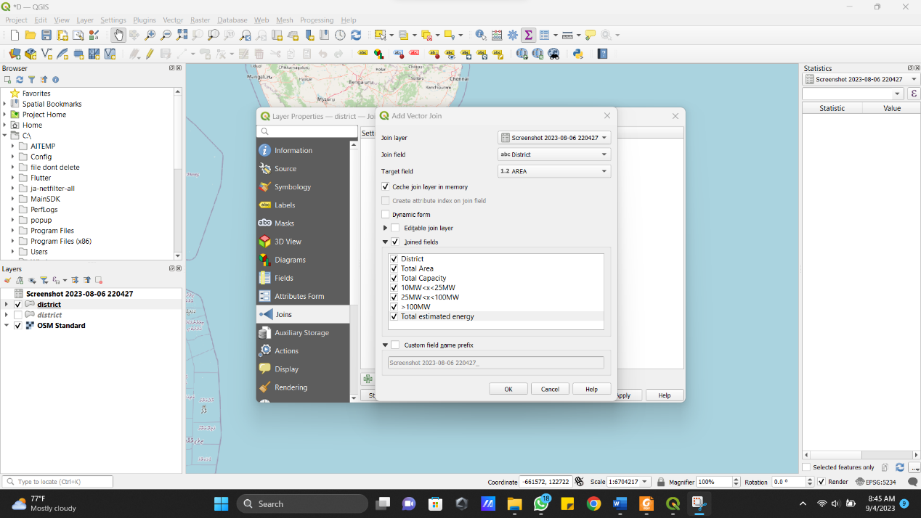

* After Jointed Dataset

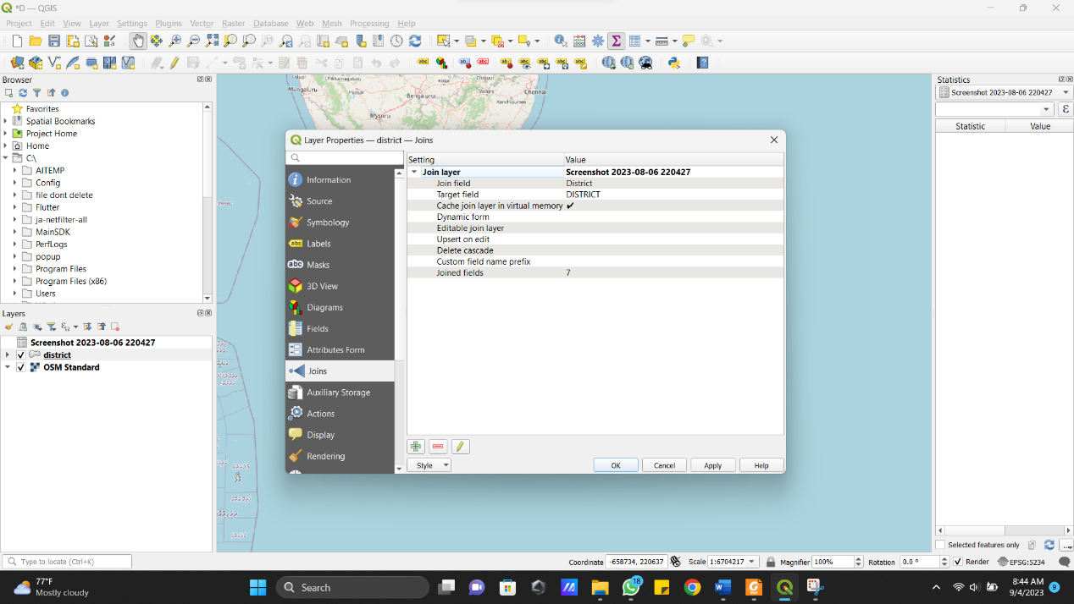

* Visualize map using total estimated energy.

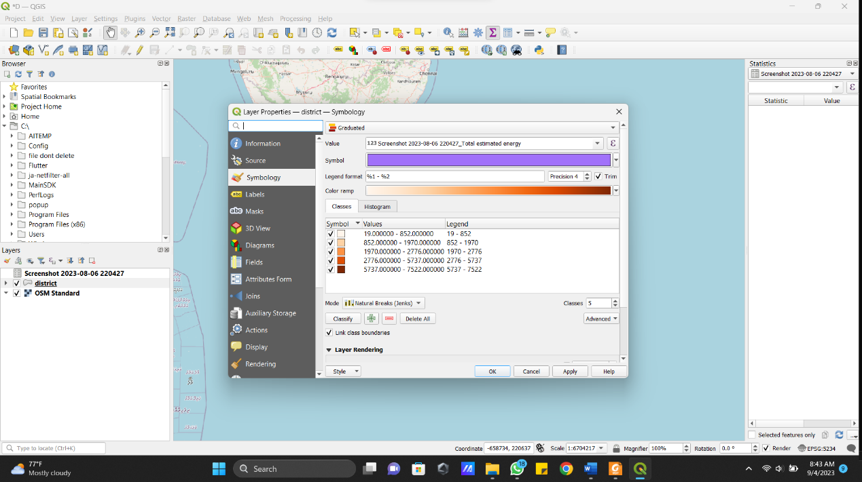

* Map labeling

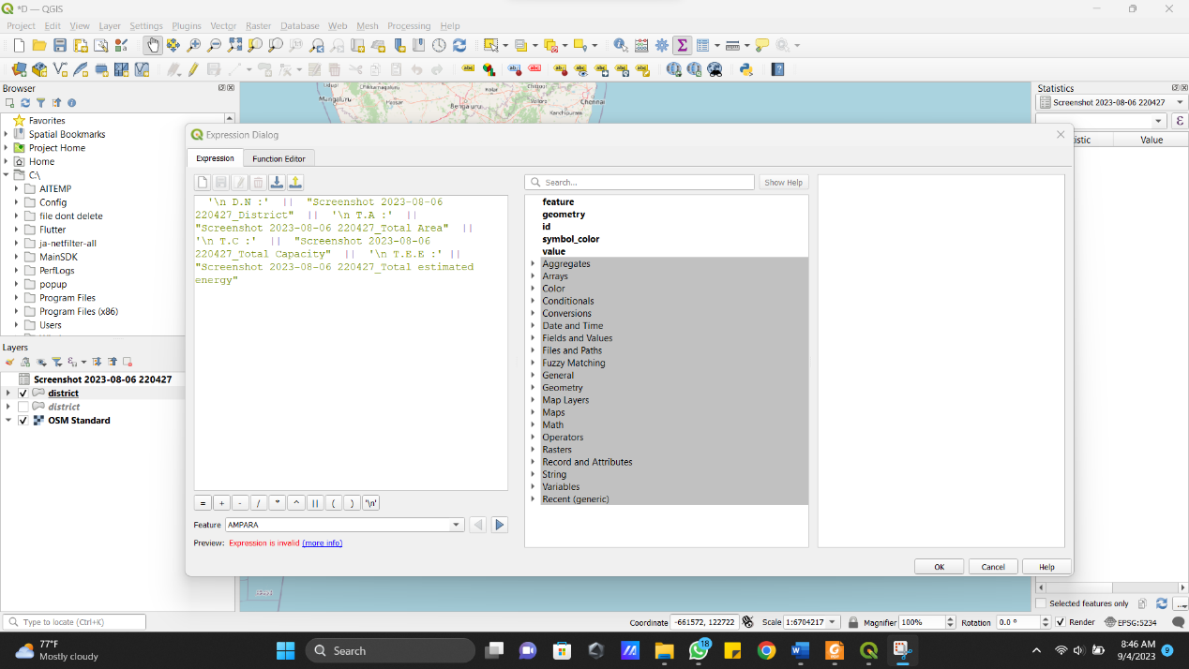

* Print view

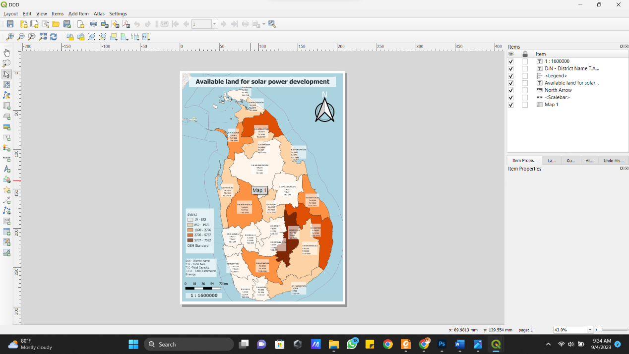

**Appendix E**

* Select OSM Map



* Select Kandawala Grid

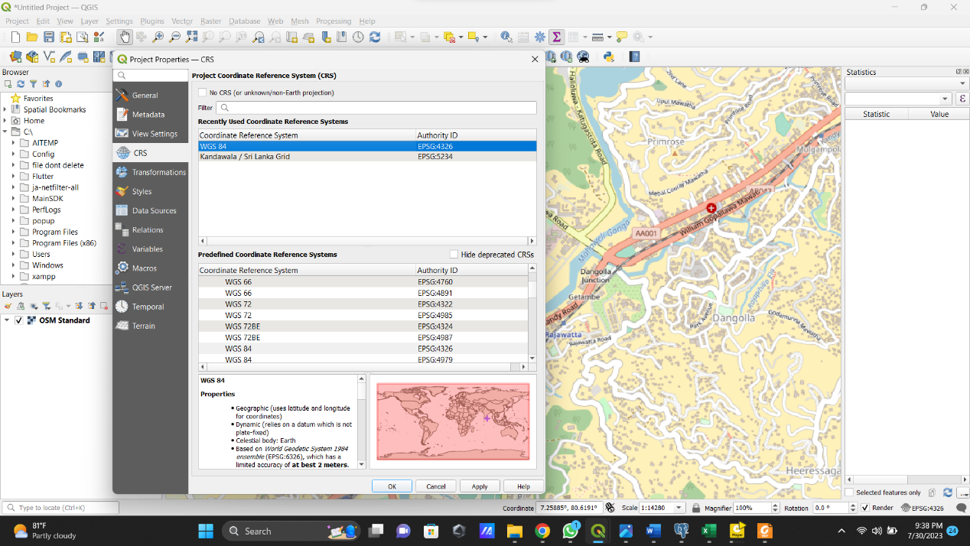

* Pinned in Georeferencer

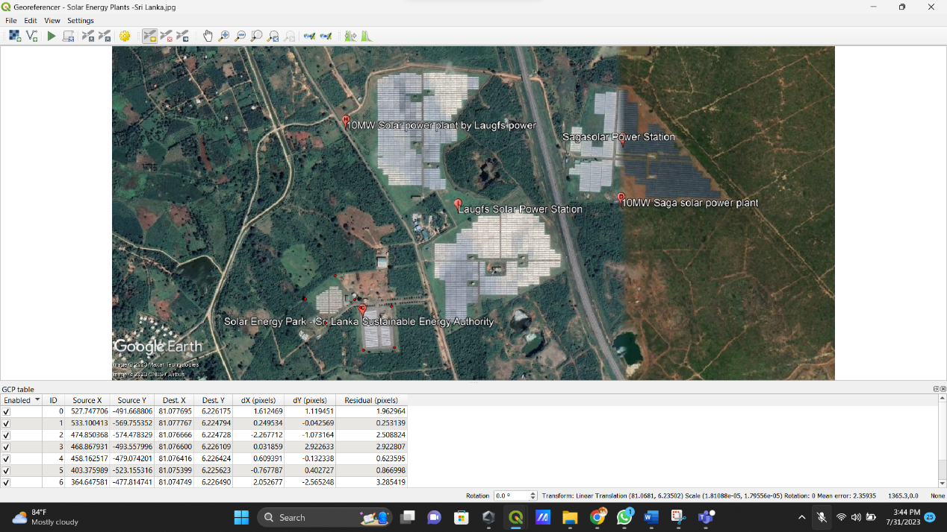

* Drow the area

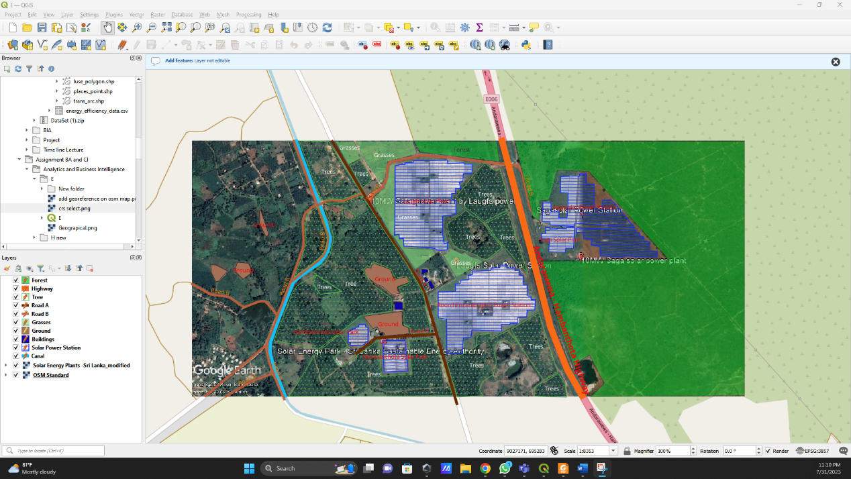

**Appendix F**

* Create database table and import the dataset using postgresql.

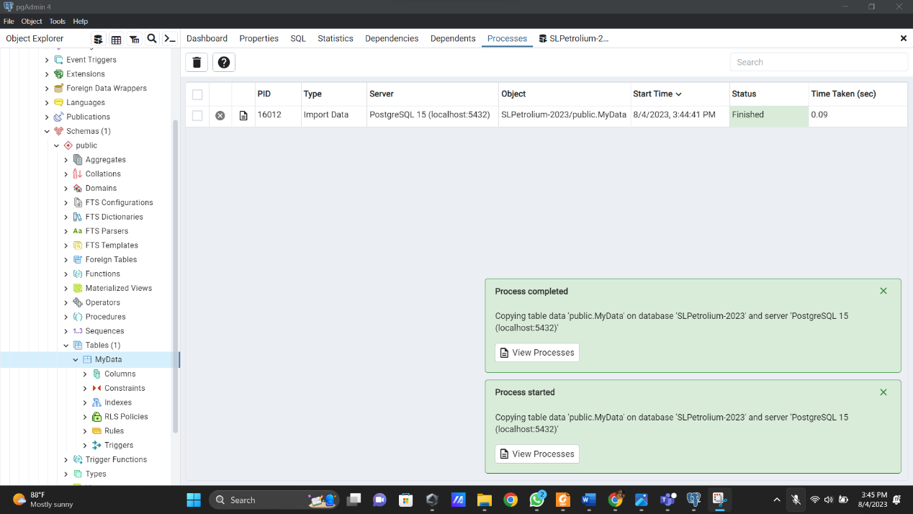

* Connect postgresql into QGIS

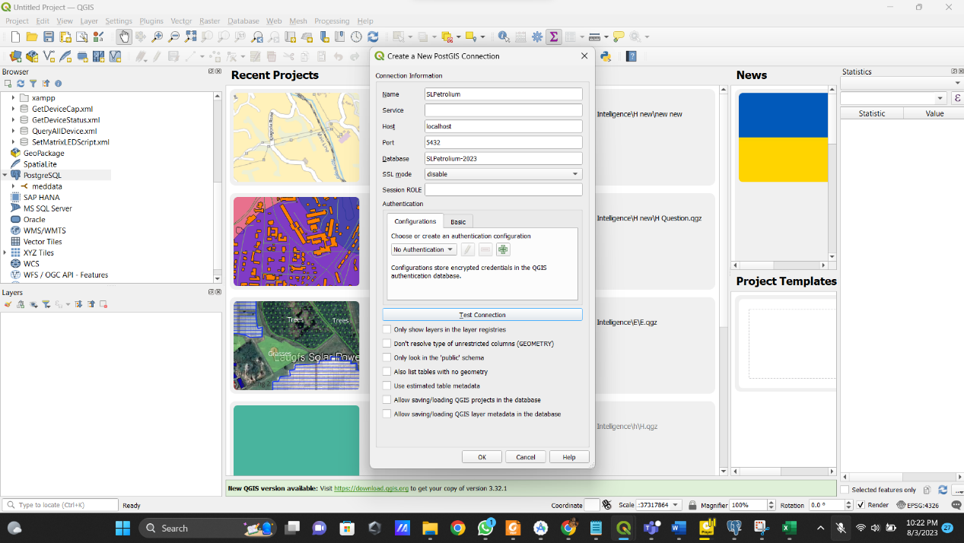

* Joined the field.

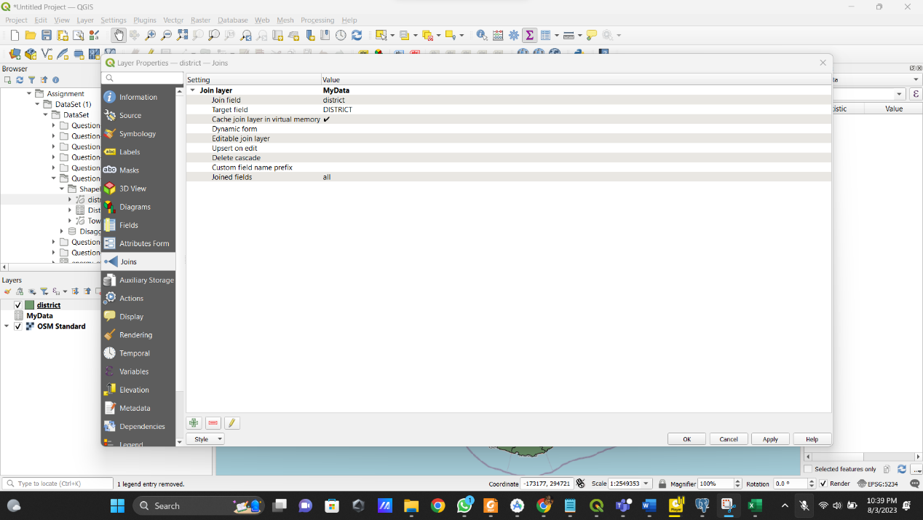

* Visualize map using no of shed.

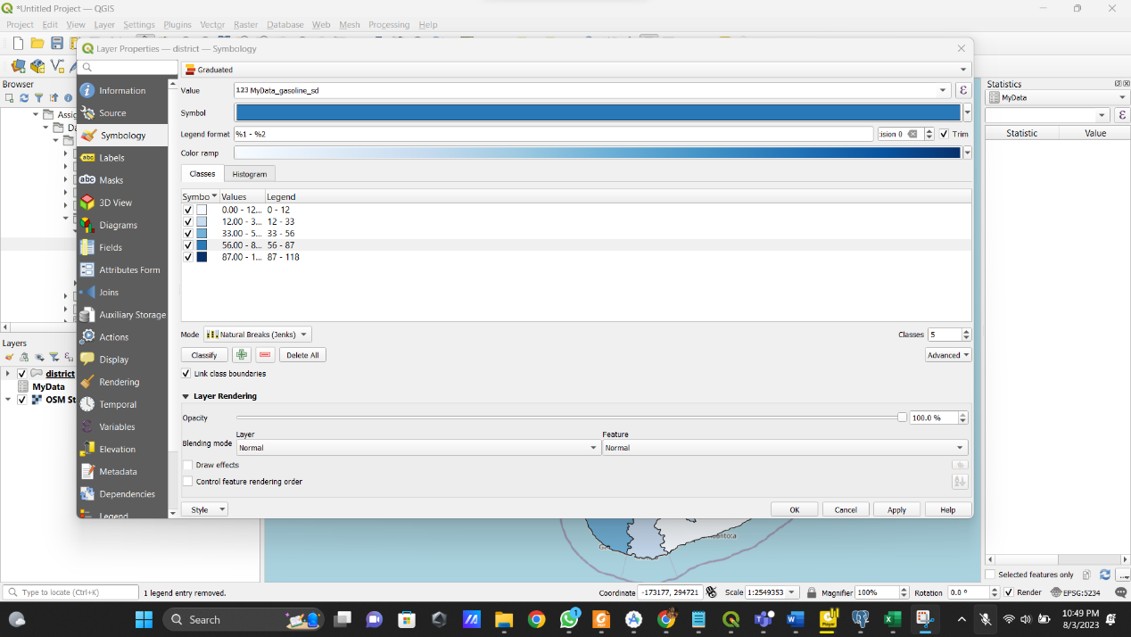

* Print View

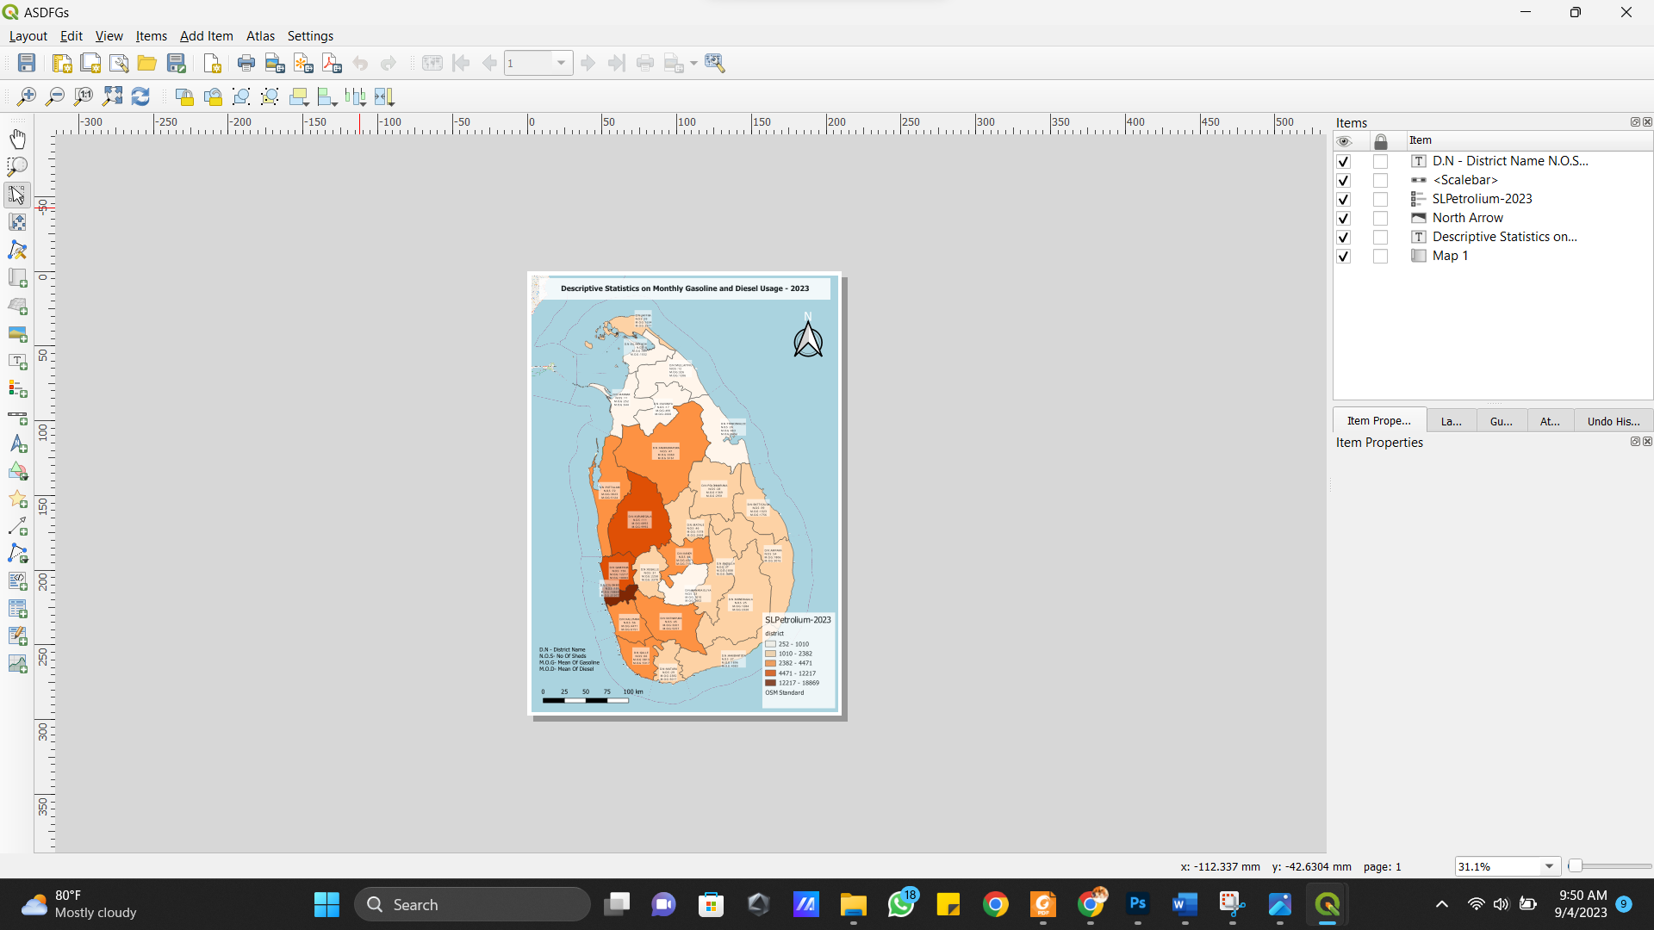

**Appendix G**

* Pined solar wind, solar, and Biomass places using Google Earth Pro

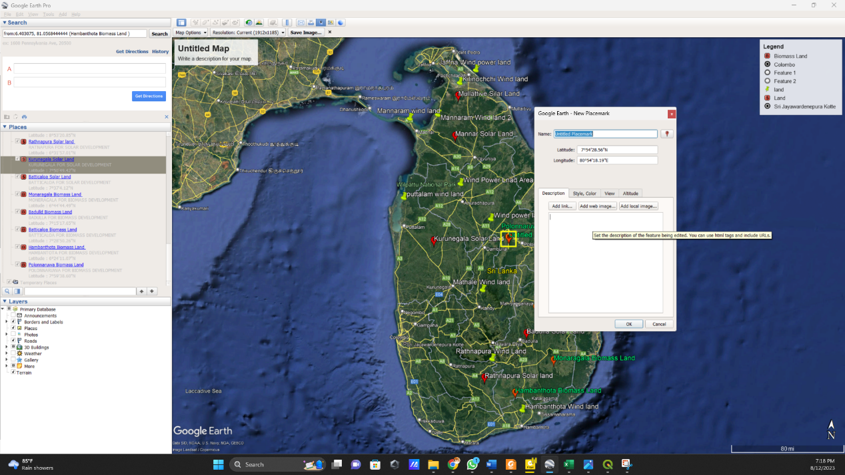

* Change Pin colors

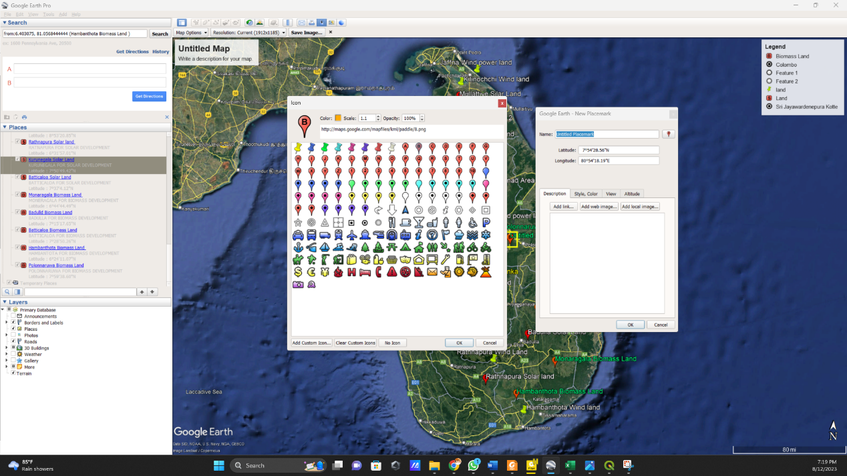

* Export KMZ File

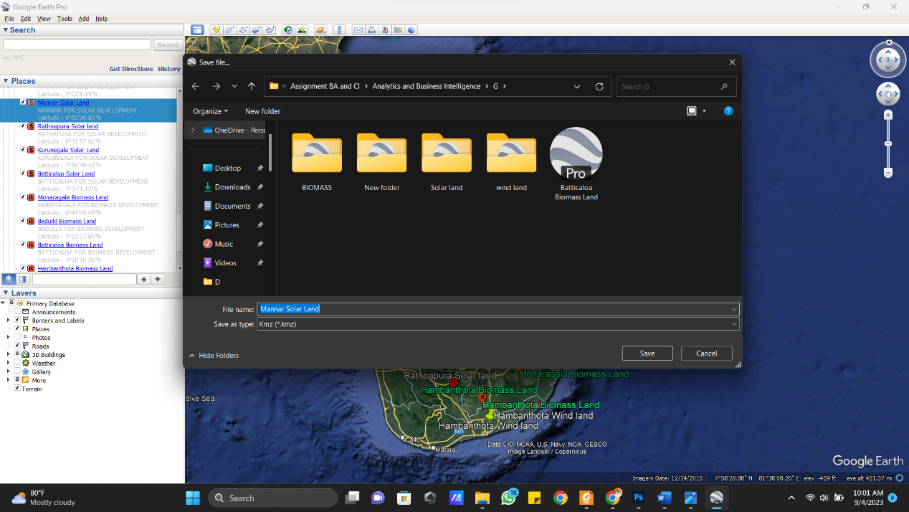

* Pined Map

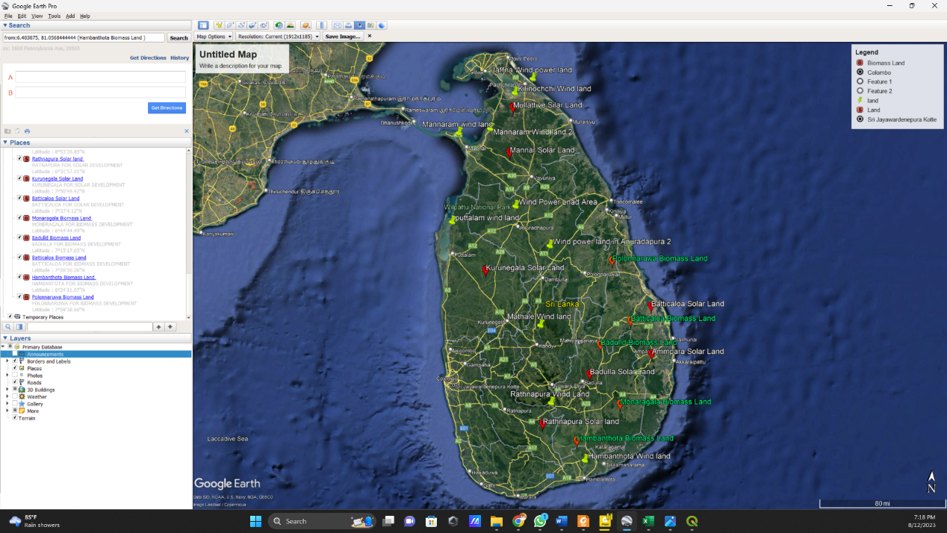

* Import Kmz File And label in to GQIS

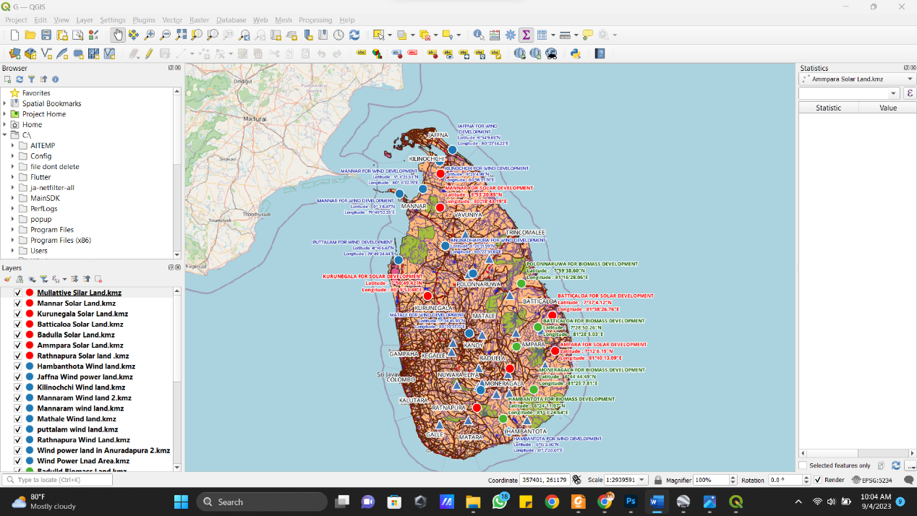

* Print view

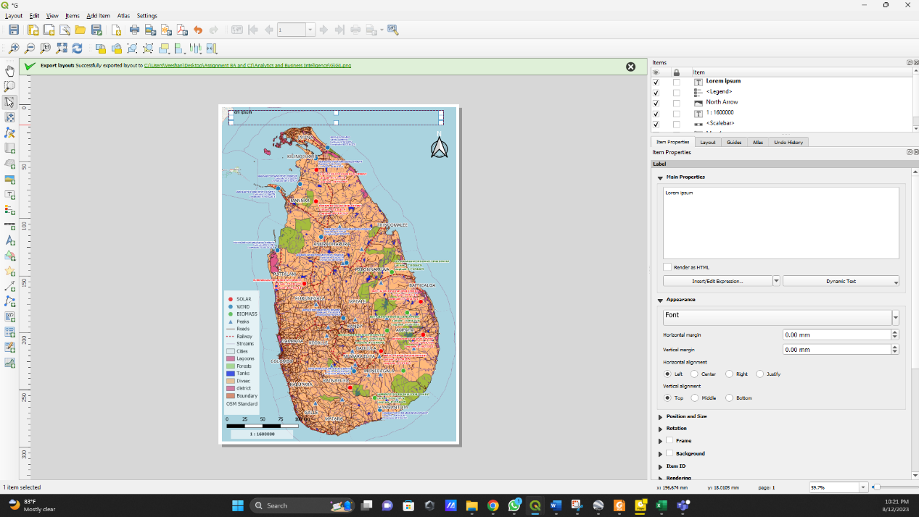

**Appendix H**

* Select OSM Map.

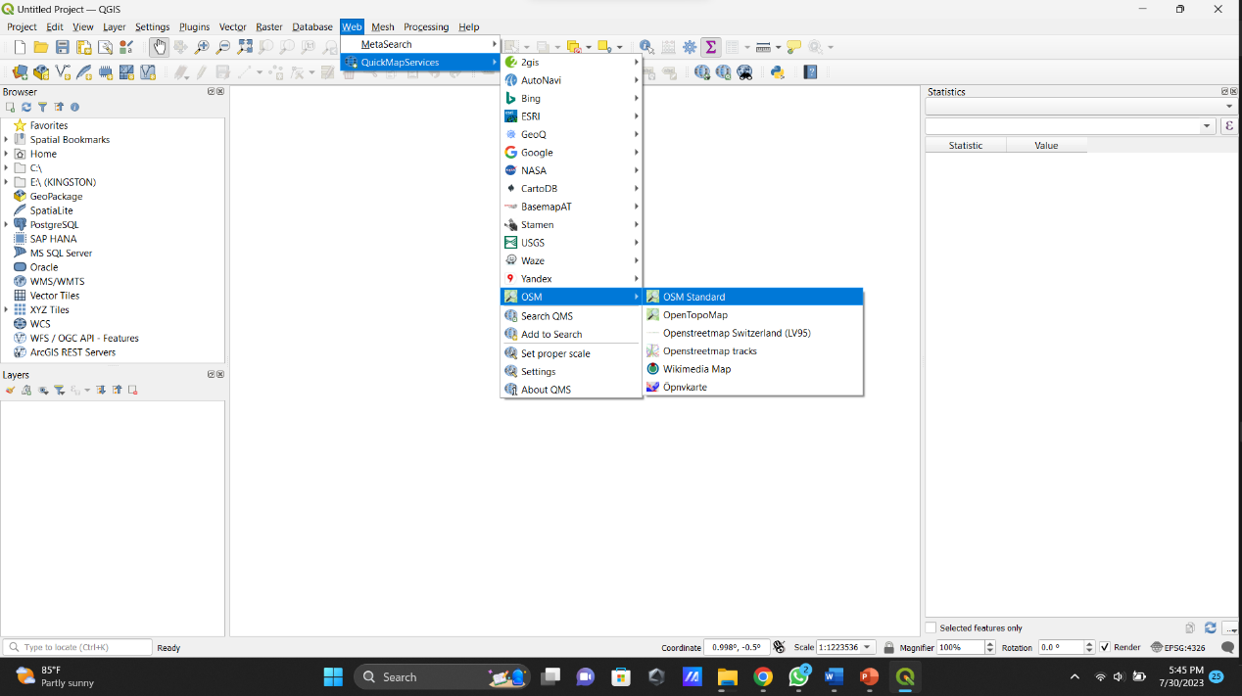

* Select WGS 84(EPS:3857)

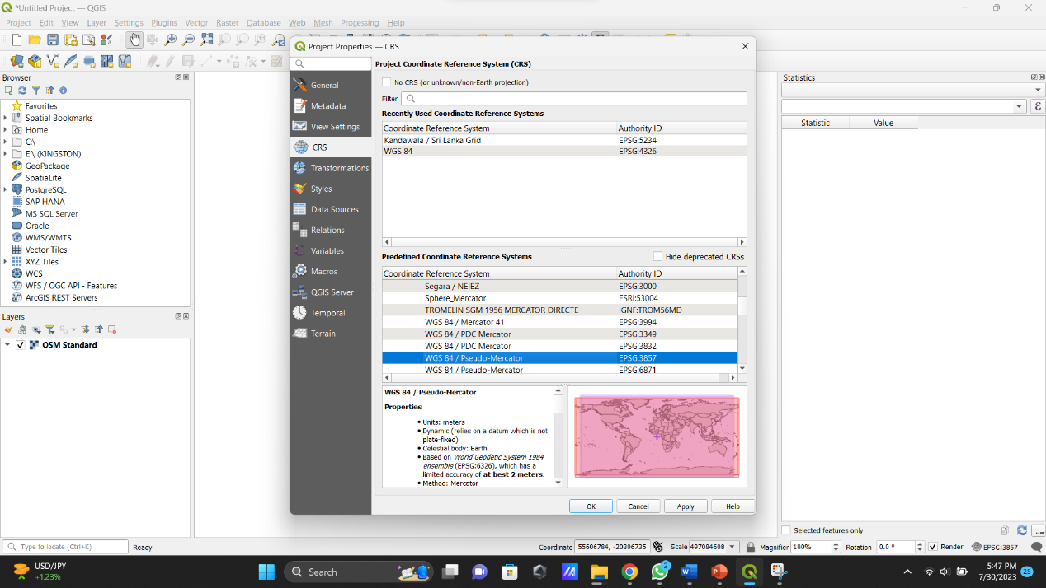

* Import shape file.

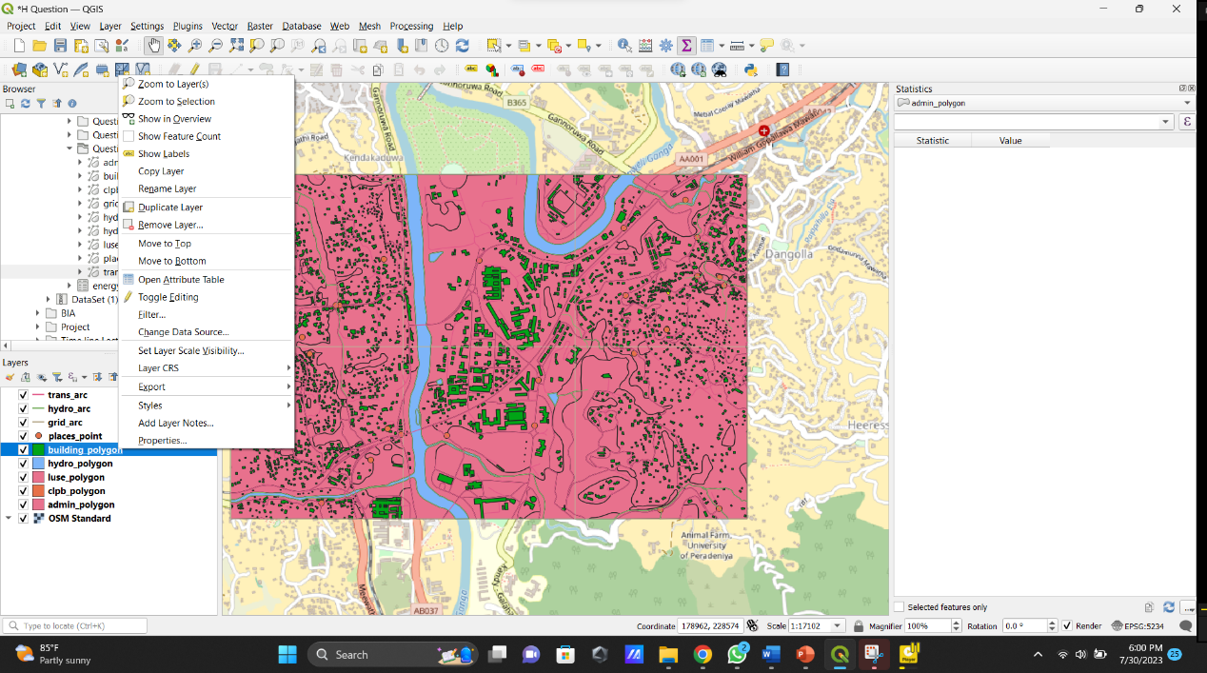

* find Uruwala Primary School

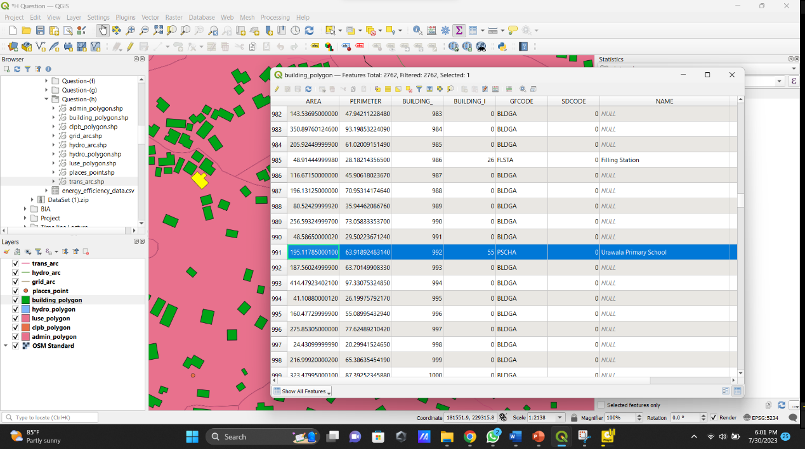

* Buffering Uruwala Primary School
* Step 1: Buffer

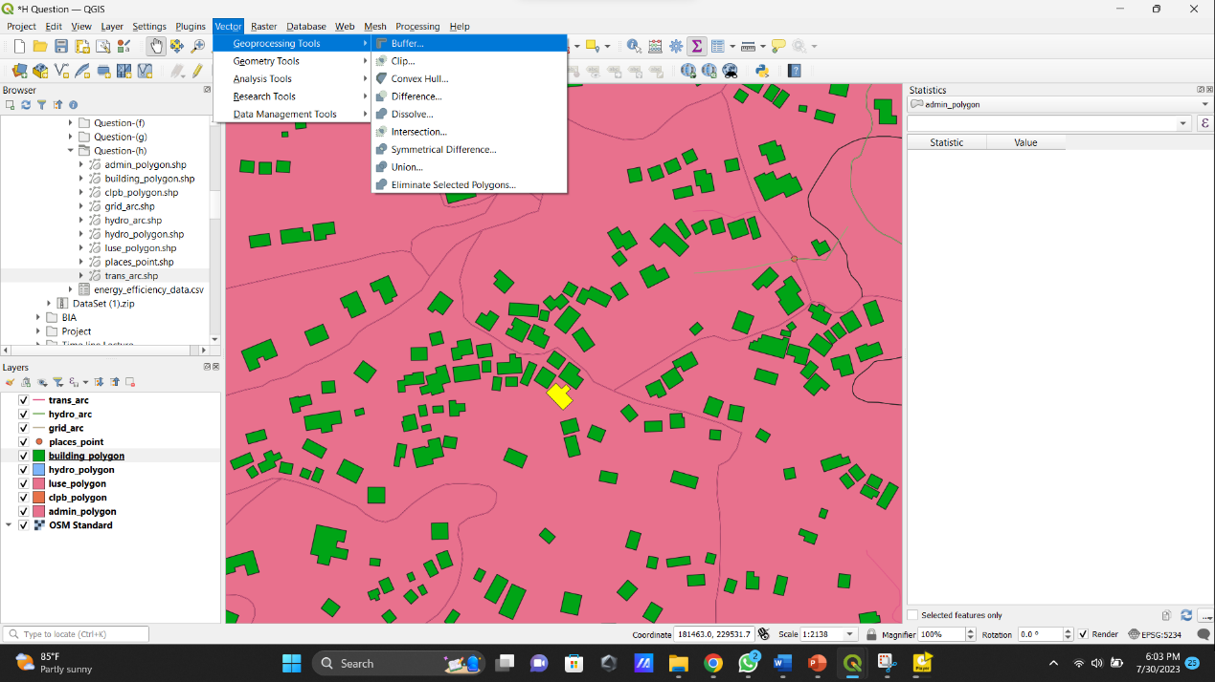

* Output

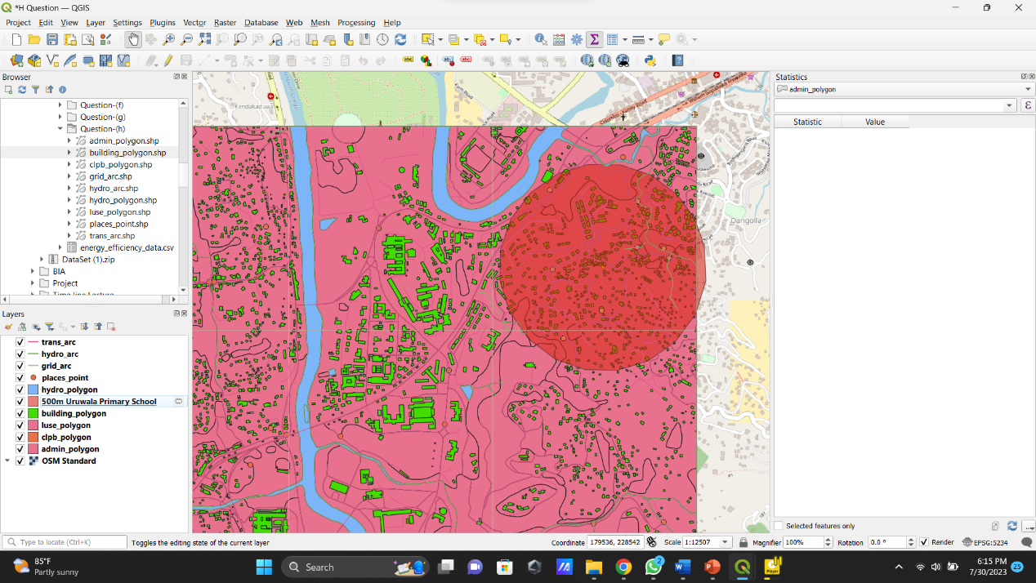

* Find Industrial Development Center

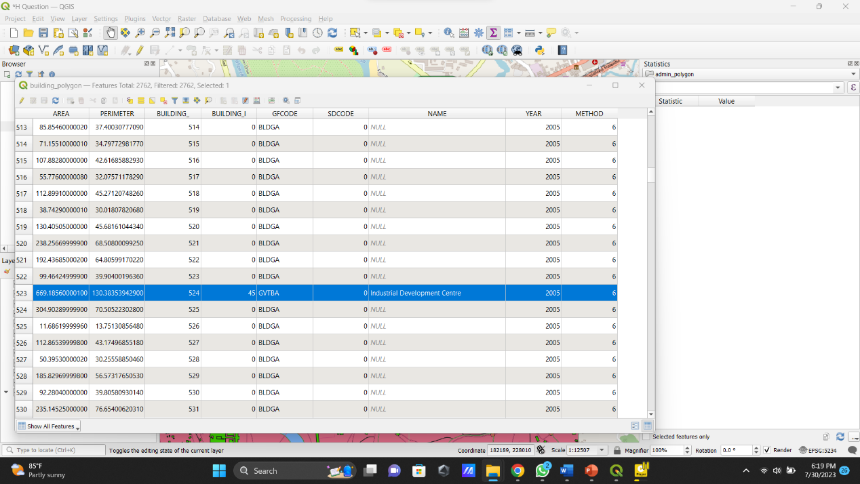

* Buffering Industrial Development Center

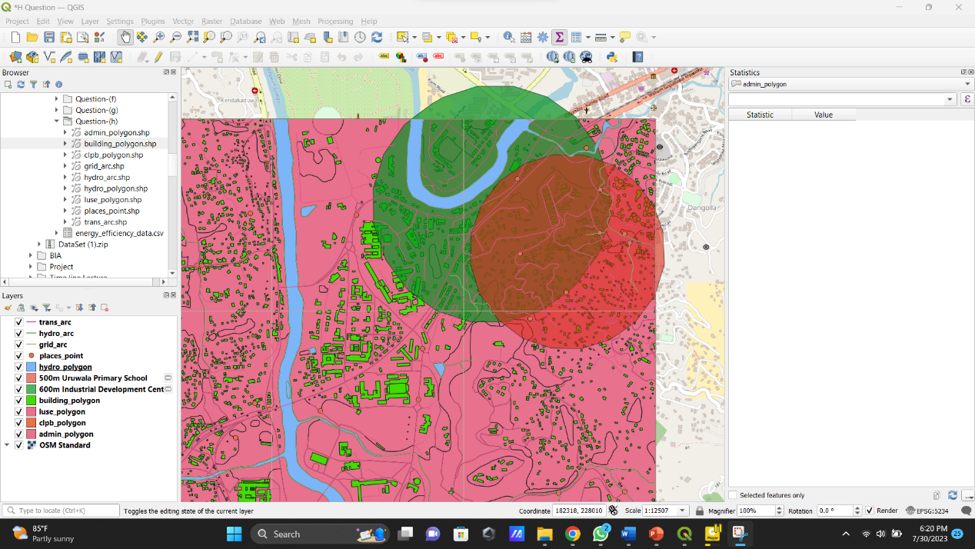

* Find Jayathilaka Hall

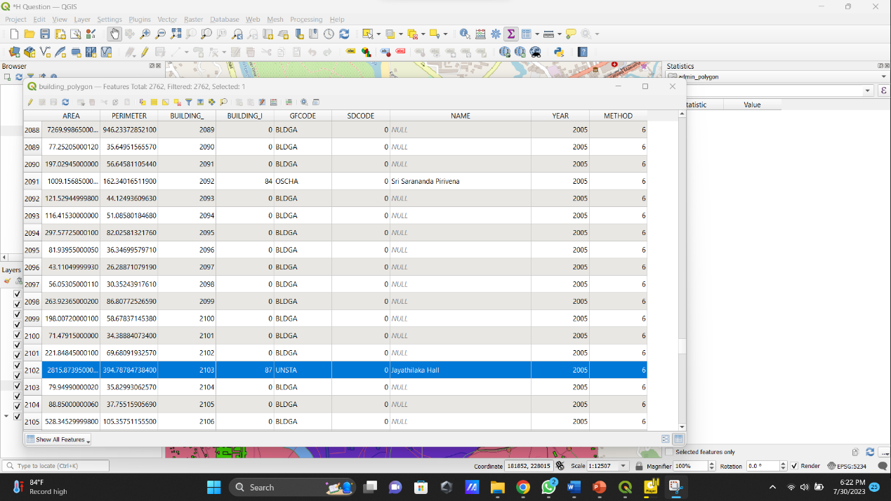

* Buffering Jayathilaka Hall

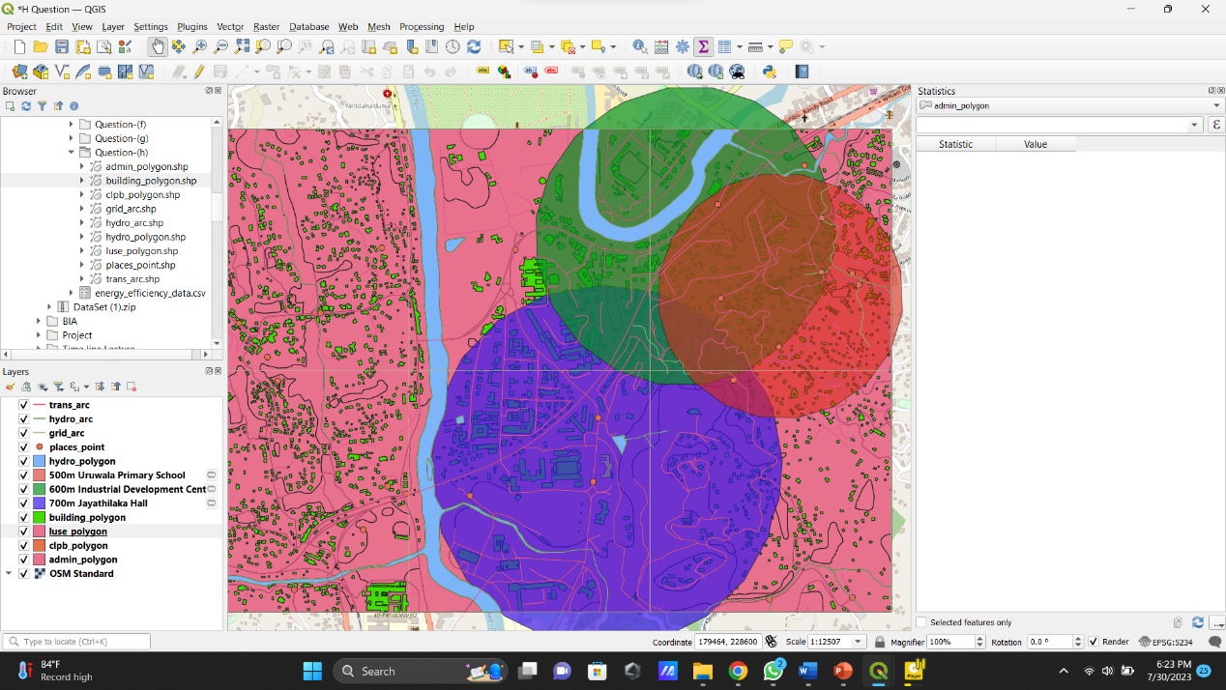

* Clipping steps

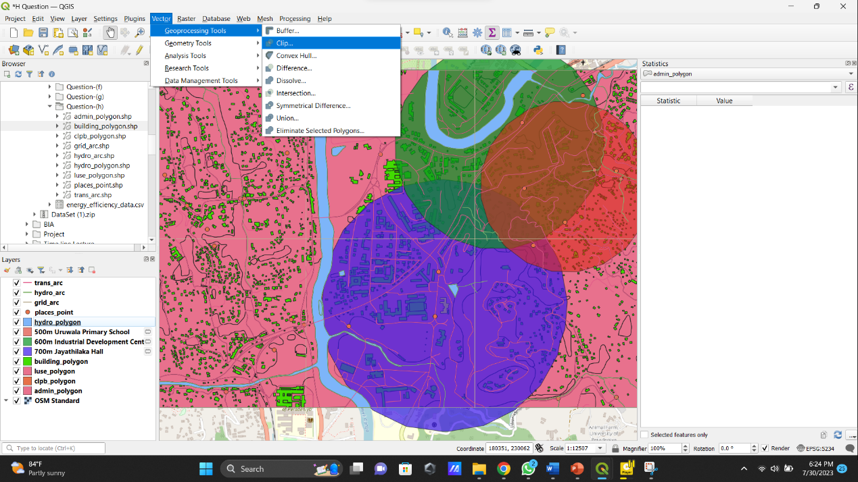

* Clipping to Uruwala Primary School and Industrial Development Center

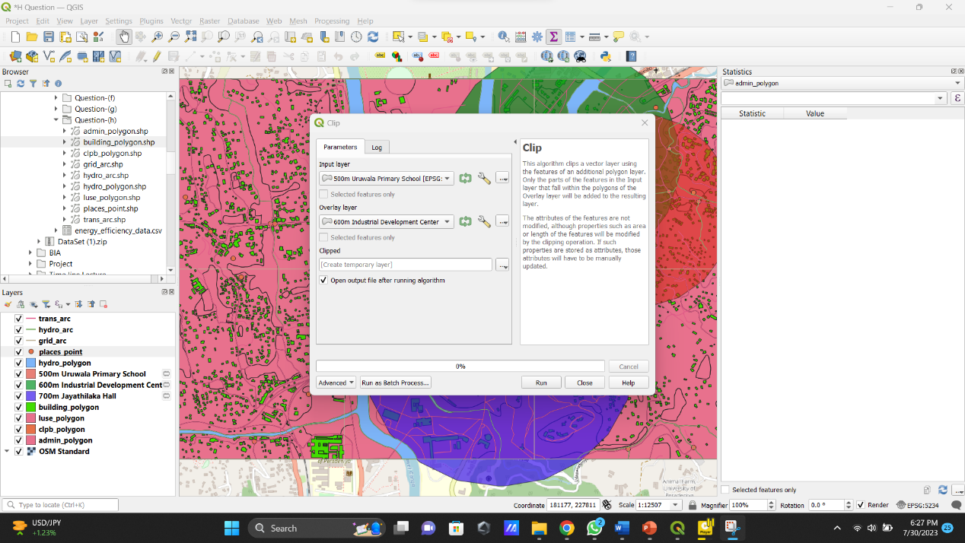

* After clipping.

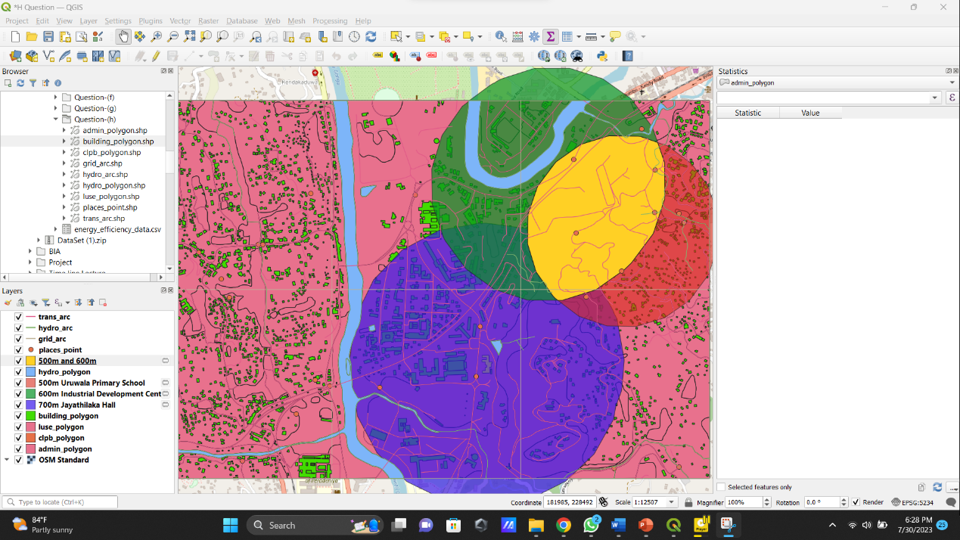

* Find suitable area After clipping between (Uruwala Primary School and Industrial Development Center) to Jayathilaka Hall

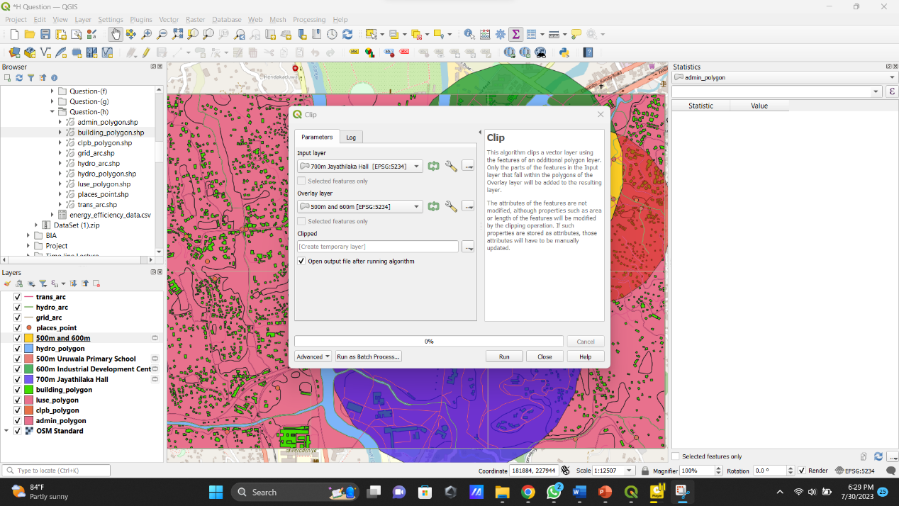

* After clipping find suitable area

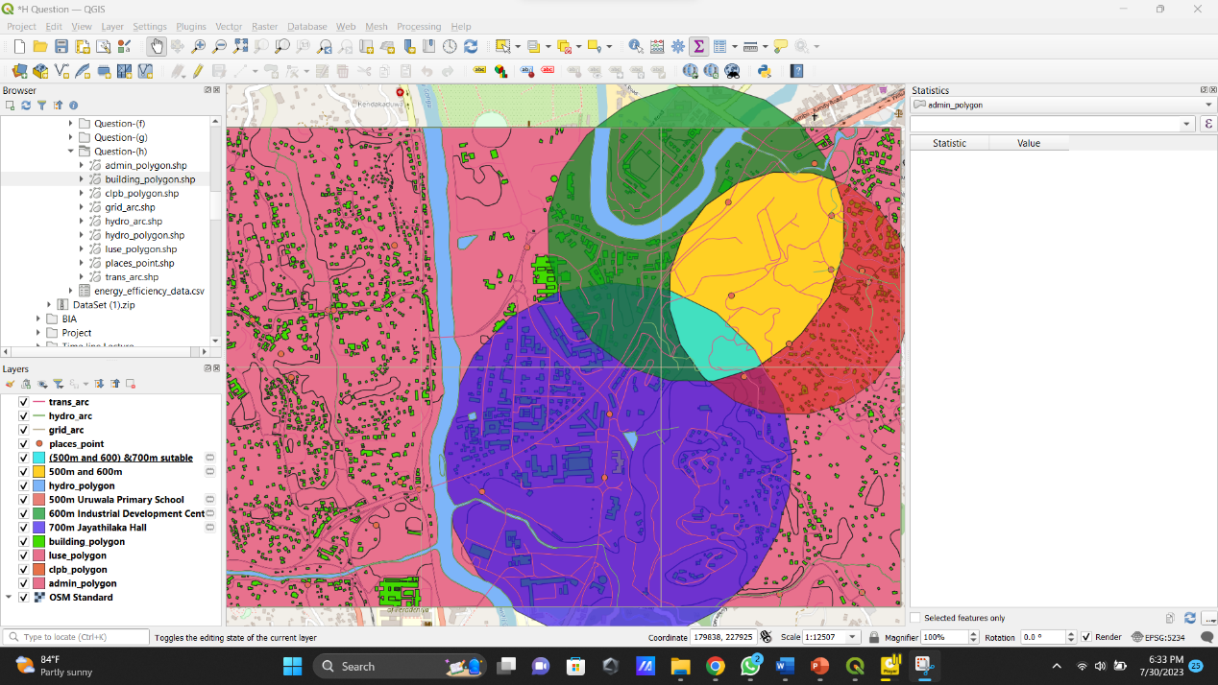

* Create an Intersection

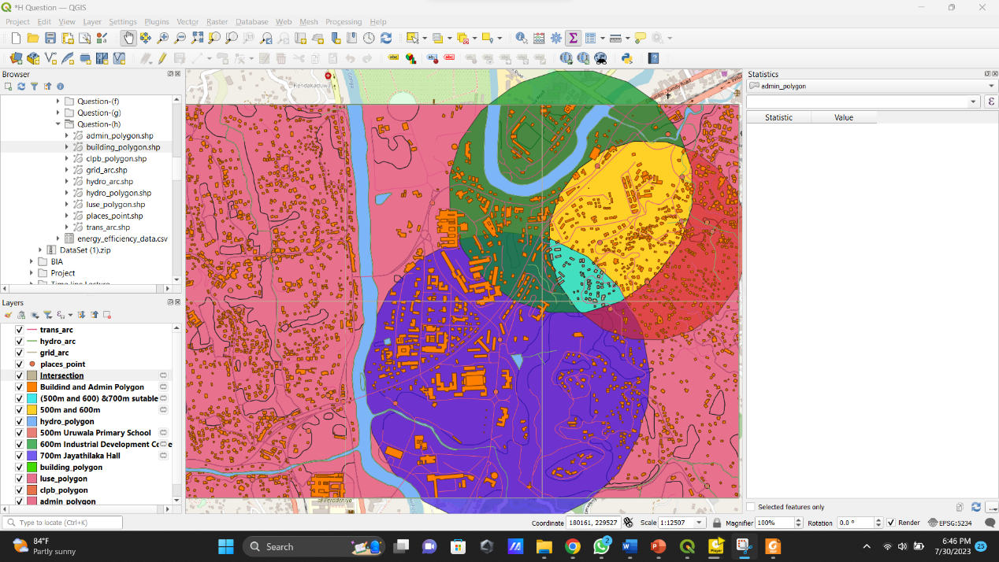

* Total suitable land area and building count.

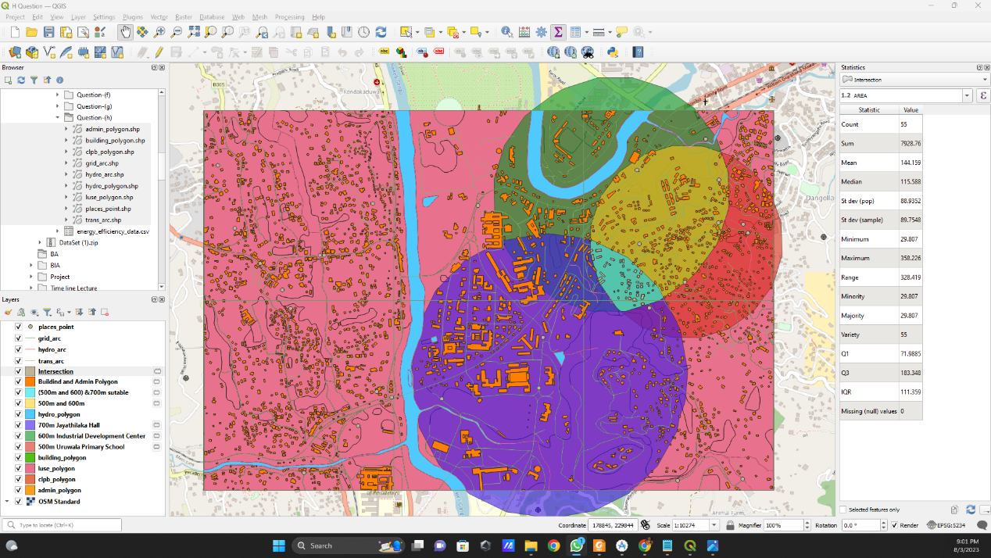

* Total land area

